**Python for Bioinformatics**

Exercise 4

IV-Title: Programs demonstrating use of Sets and Dictionaries

1. Write a program demonstrating declaration and accessing of Sets and its elements.

Algorithm:

Step 1:- A set is created by placing all the items (elements) inside curly braces {}, separated by comma, or by using the built-in set() function.

Step 2:- You can access the set by printing the variable to which the set is assigned.

Answer: Program demonstrating accessing of Sets:

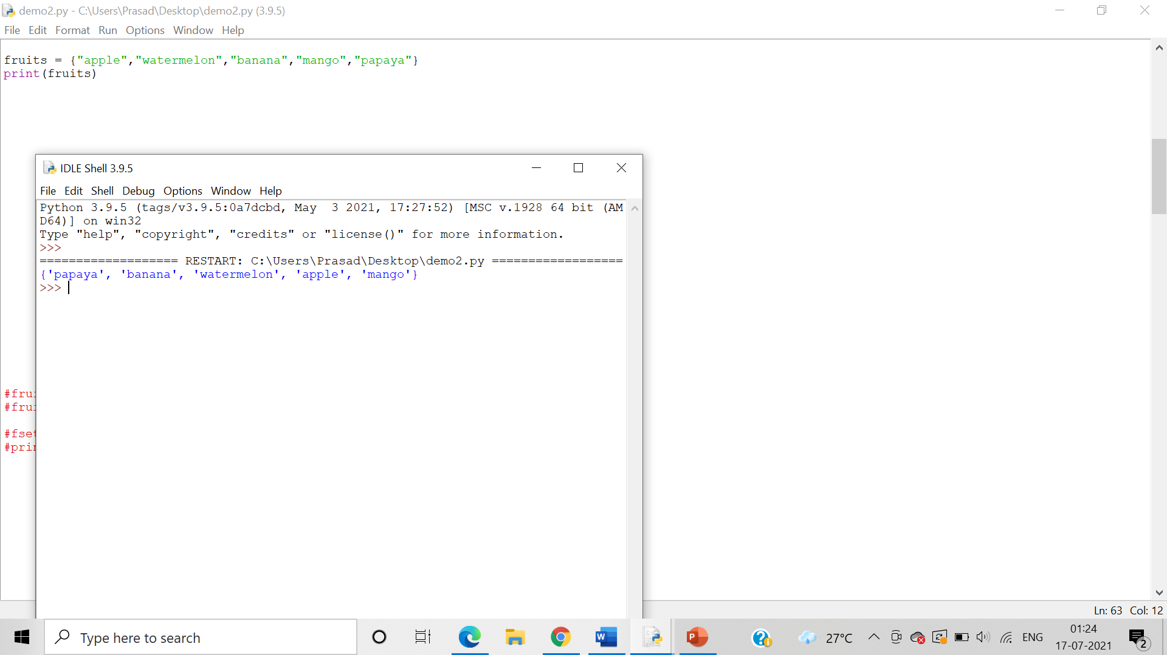

2. Write a program demonstrating len() and del() function on Sets.

Algorithm:

Step 1:   The len() function is used to obtain the length of the set.

Step 2: The del() function **deletes all the elements in range** starting from index ‘a’ till ///////////////‘b’ mentioned in arguments of the set.

Answer: Program demonstrating len() function on Sets:

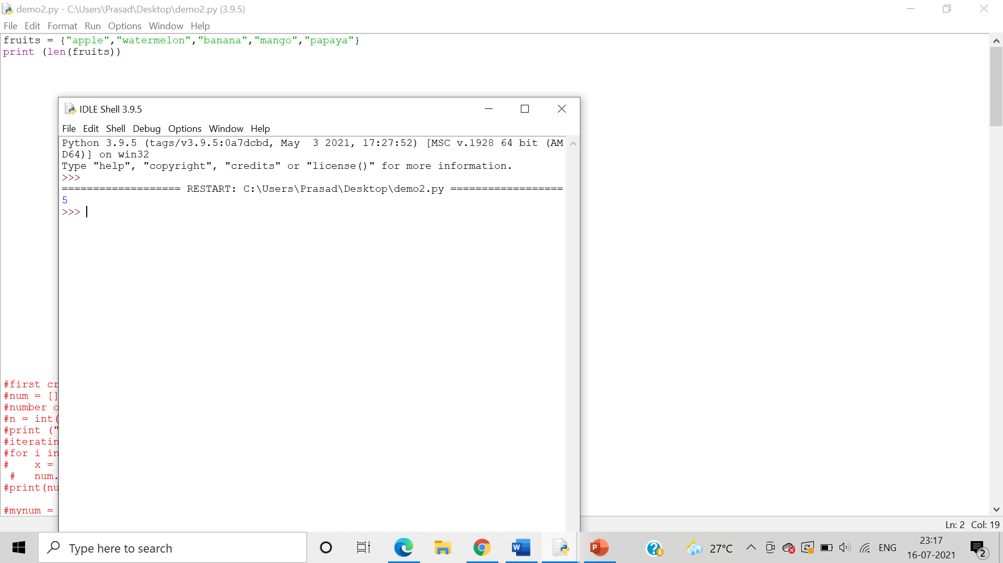

Program demonstrating del() function on Sets:

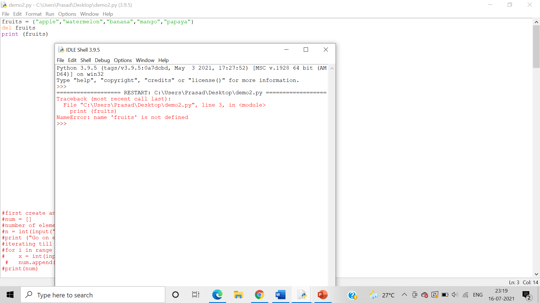

3. Write a program demonstrating input of Set elements from the user

Algorithm:-

Step 1:-Take user input

Step 2:-Use the split() function to split the values stored and assign it to the lists variable/

Step3:- Use the set() function to store the values stored in the lists variable to convert it onto a set, Assign it to a sets variable

Step 4:- Print the sets variable.

Answer: Program for demonstrating input of Set elements from the user

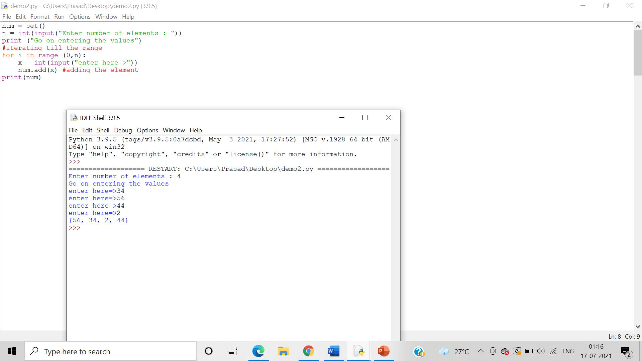

4. Write set of programs for demonstrating the usage of all the different Set methods along with their variations

Algorithm:-

Step 1:- To add one item to a set use the add() method.

Step 2:- The clear() method empties the set

Step3:- The copy() method returns a copy of the set.

Answer: Program for demonstrating add()

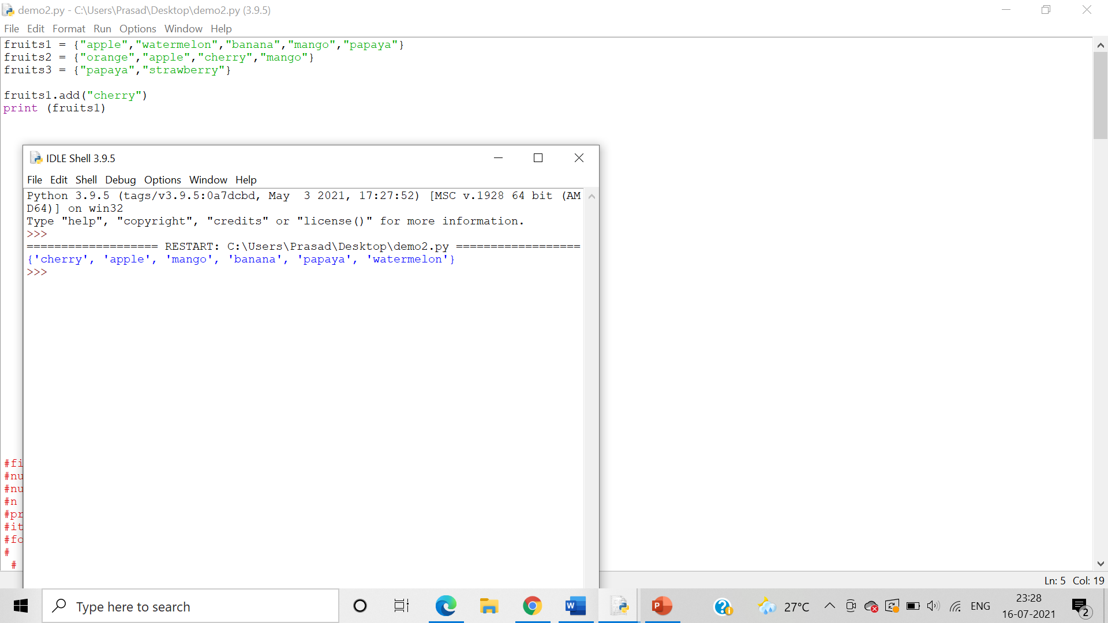

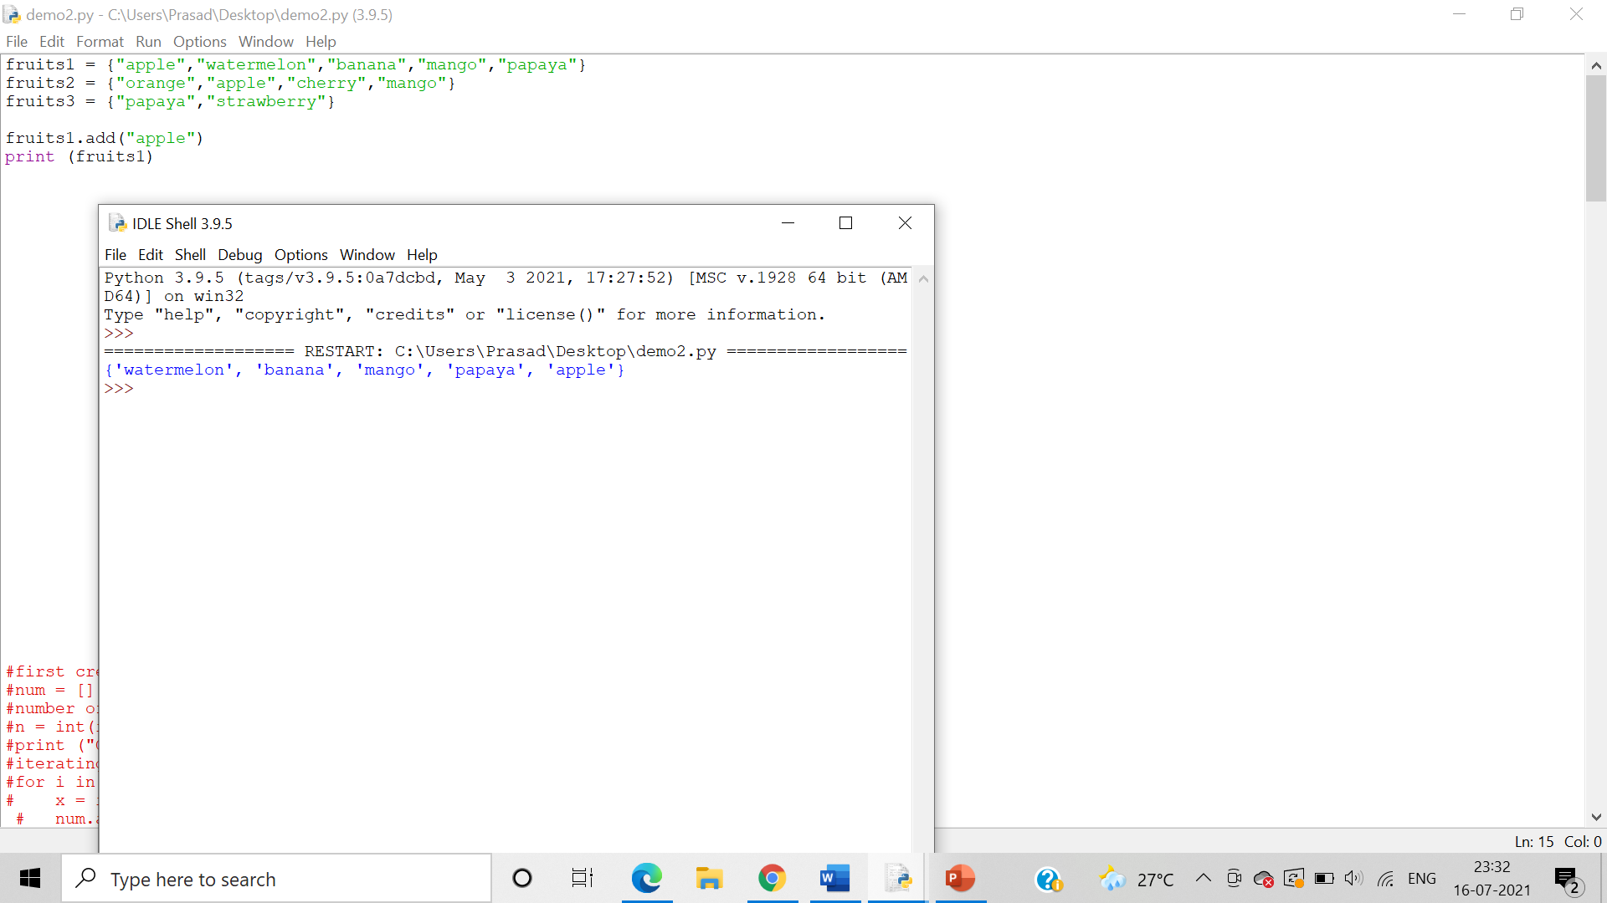

Program for demonstrating clear()

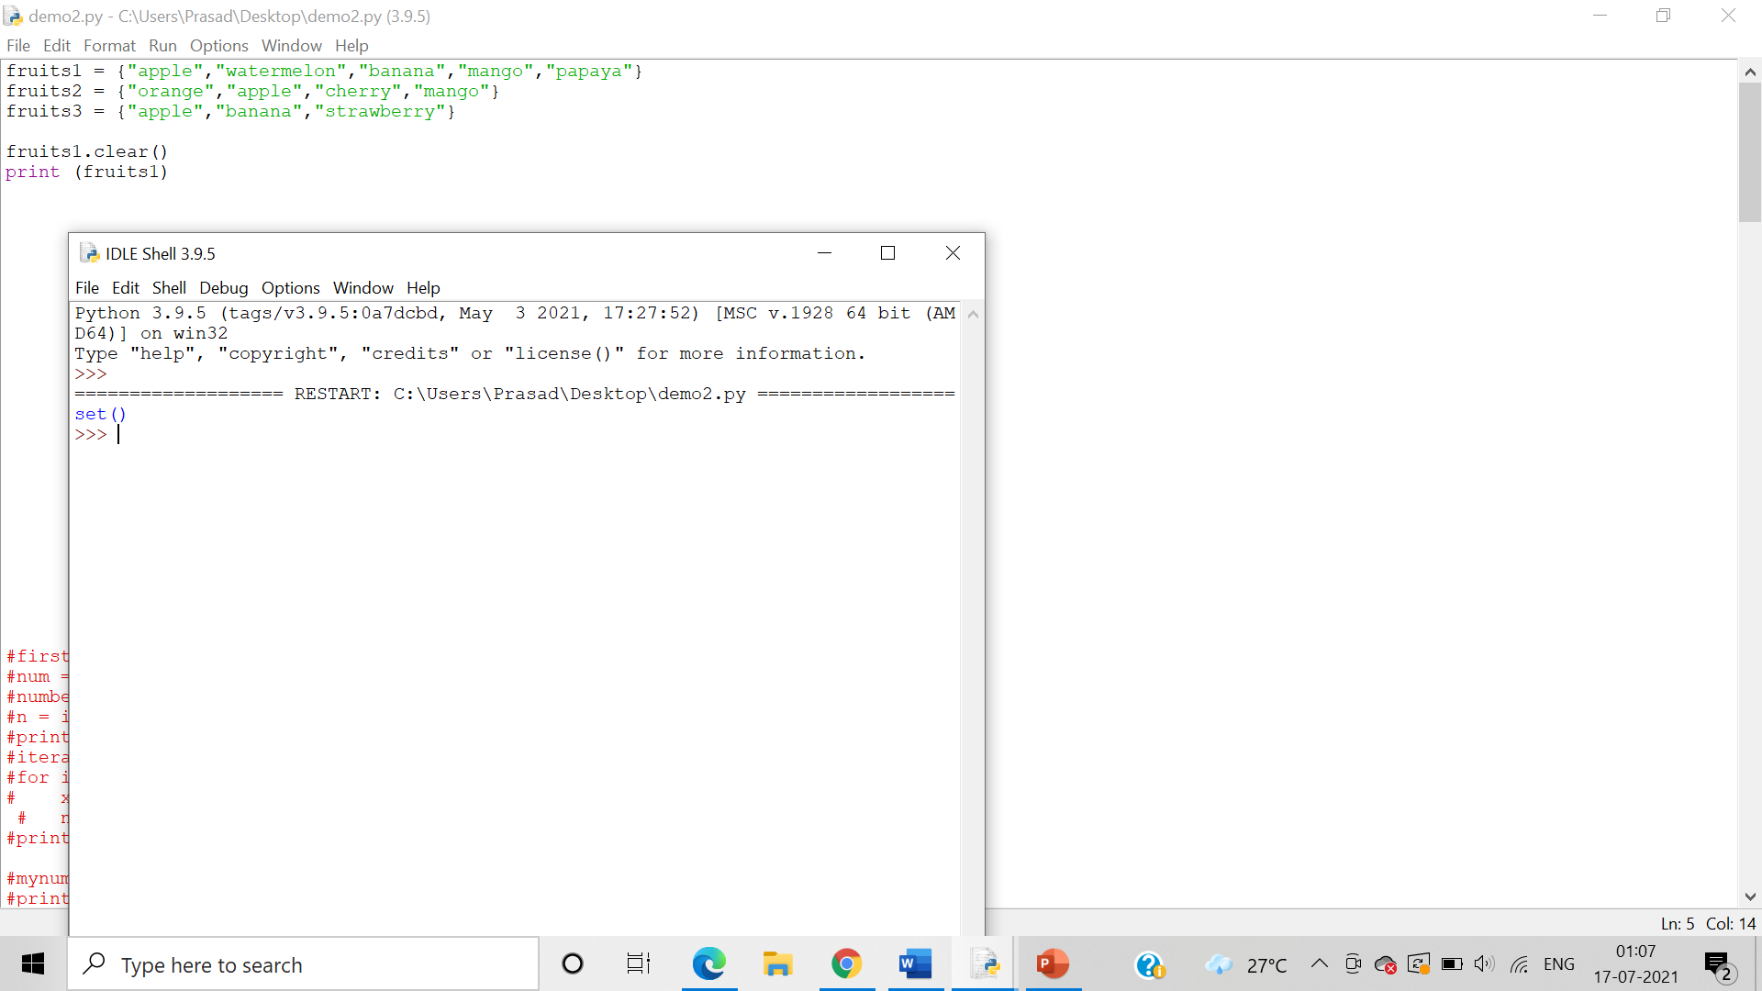

Program for demonstrating copy()

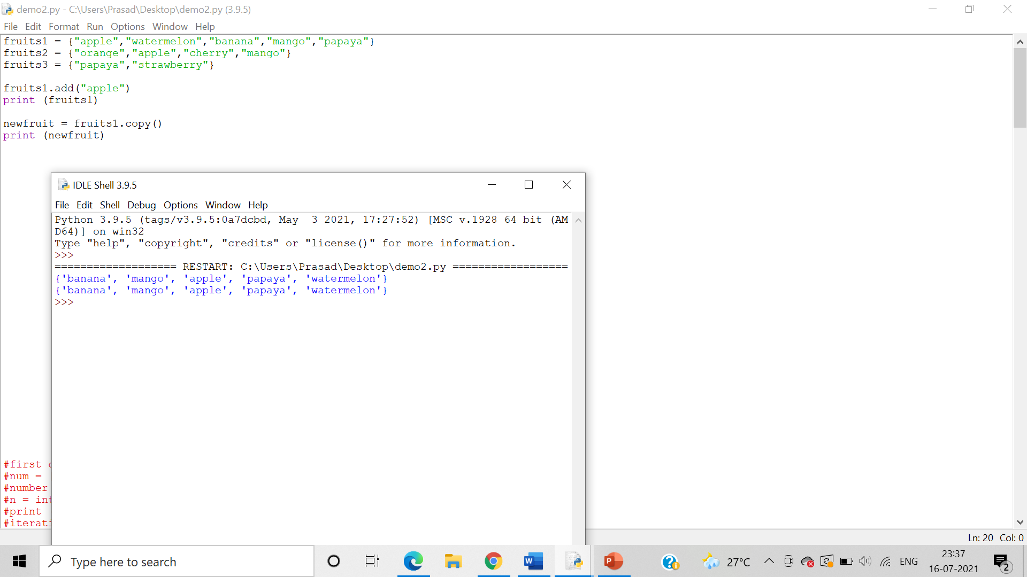

Program for demonstrating difference()

Algorithm:-

Step 1:-Diference() method returns a set containing the difference between two or more sets.

Step 2:-Diference_update() removes the items in this set that are also included in another, specified set.

Step3:- Discard() method removes the specified item.

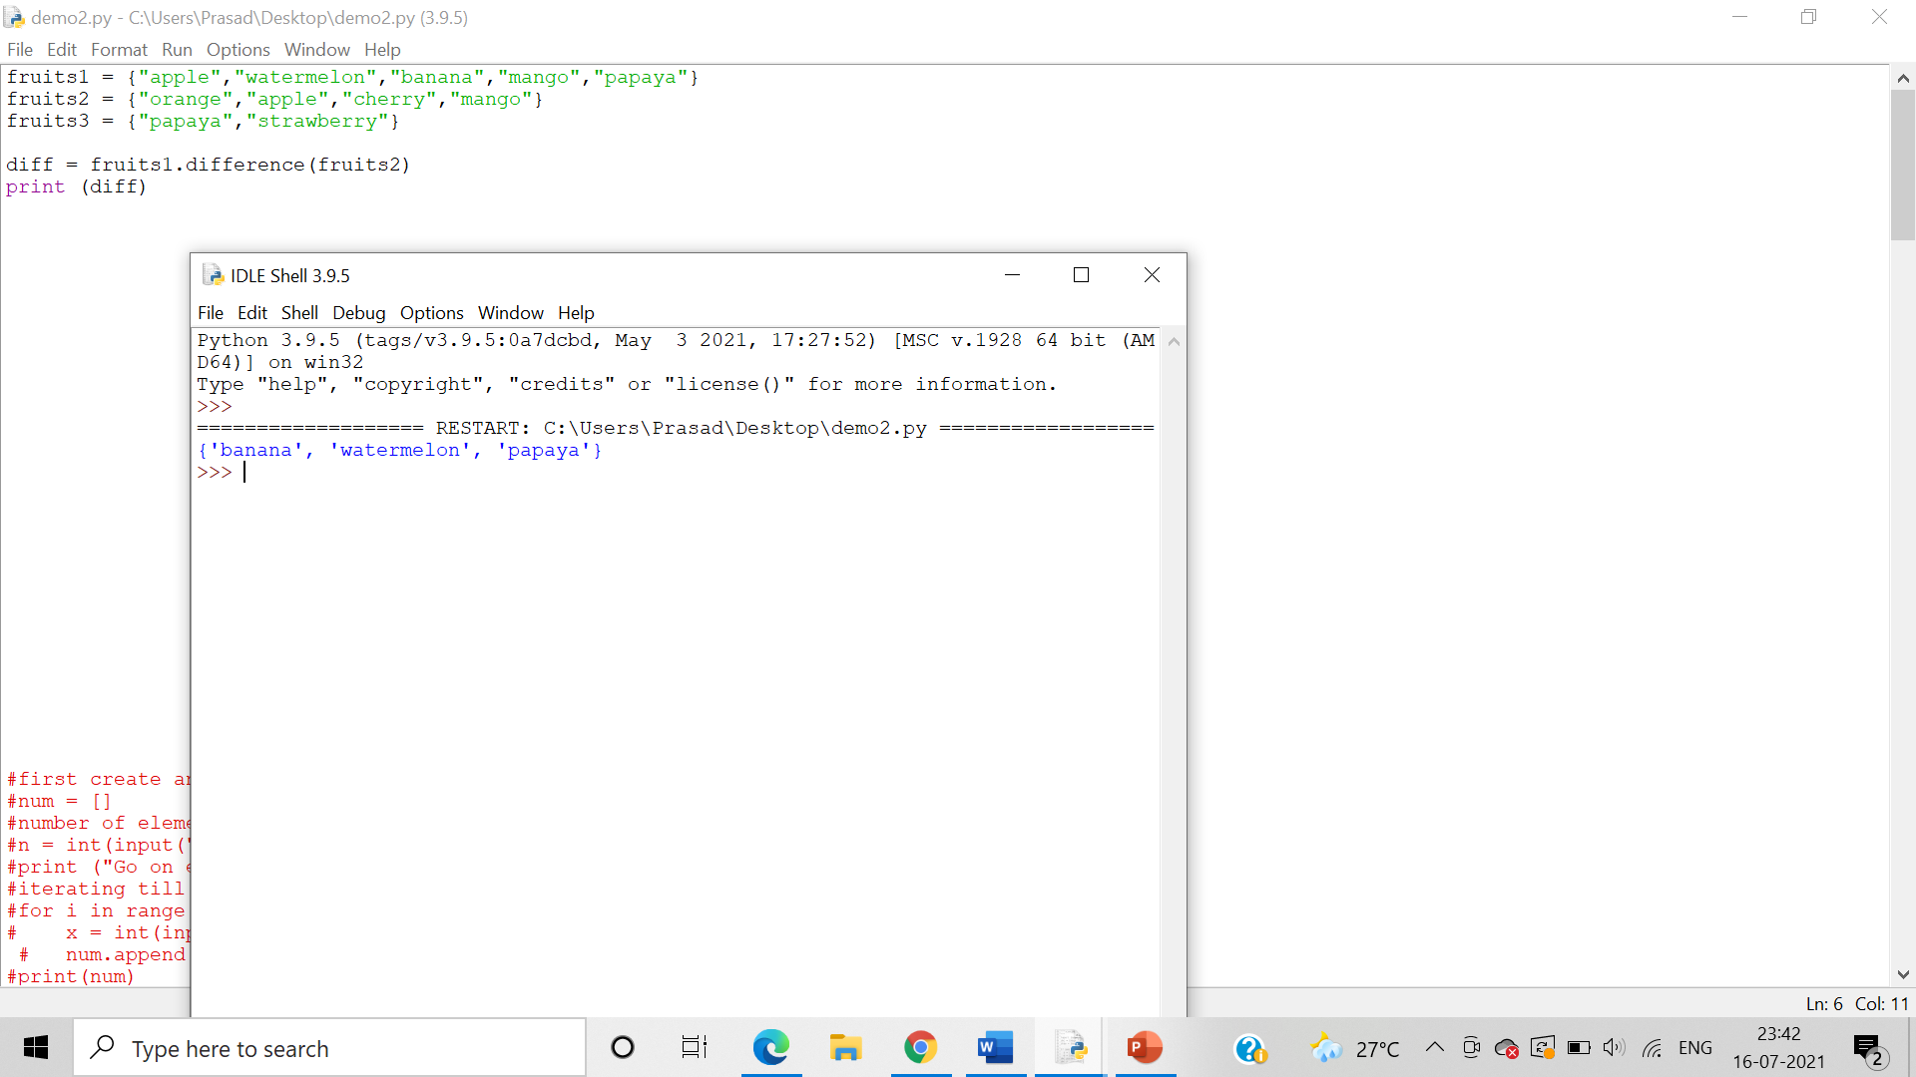

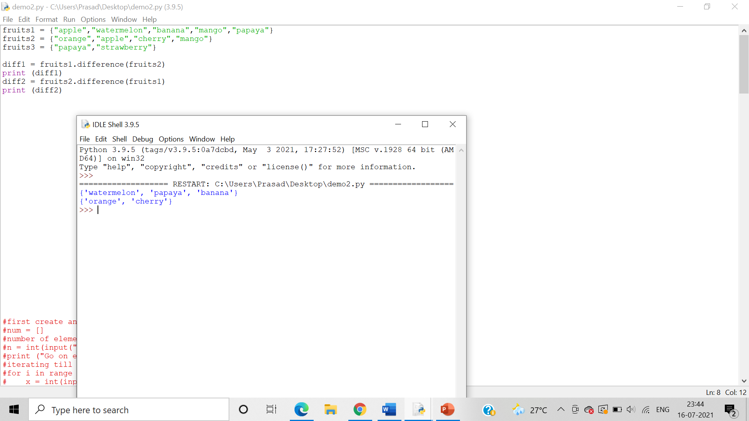

Program for demonstrating update()

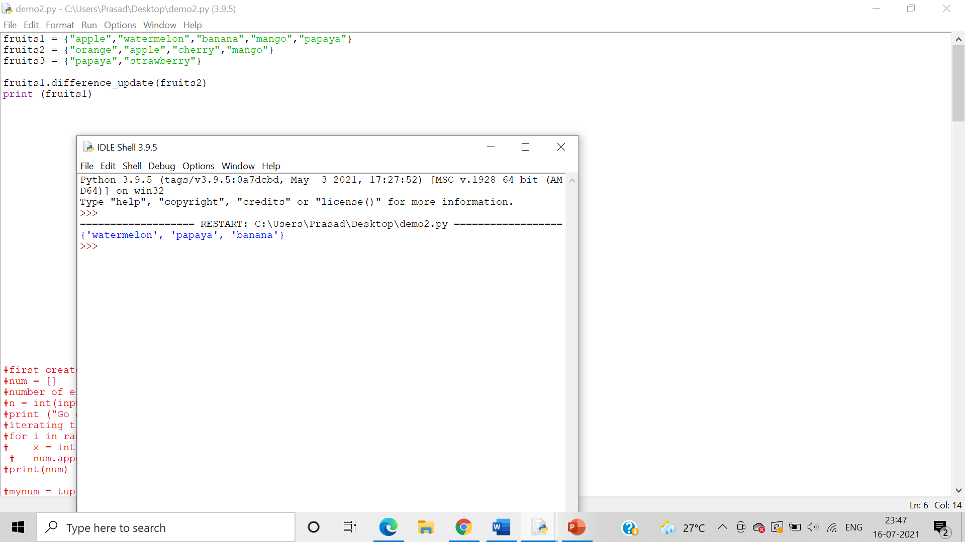

Program for demonstrating difference_update()

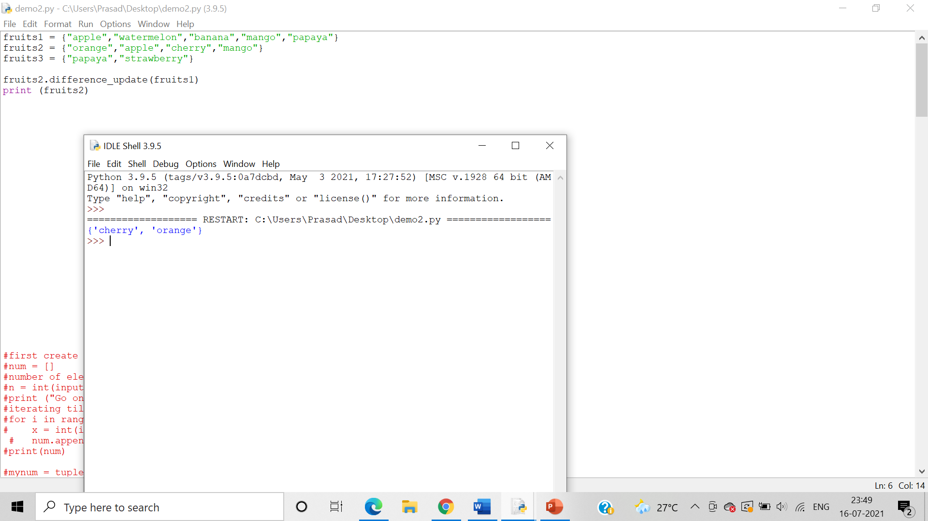

Program for demonstrating intersection()

Algorithm:-

Step 1:- intersection() method returns a set, that is the intersection of two other sets

Step 2:- intersection_update() method removes the items in this set that are not present in other, specified set.

Step3:- isdisjoint() method returns whether two sets have a intersection or not.

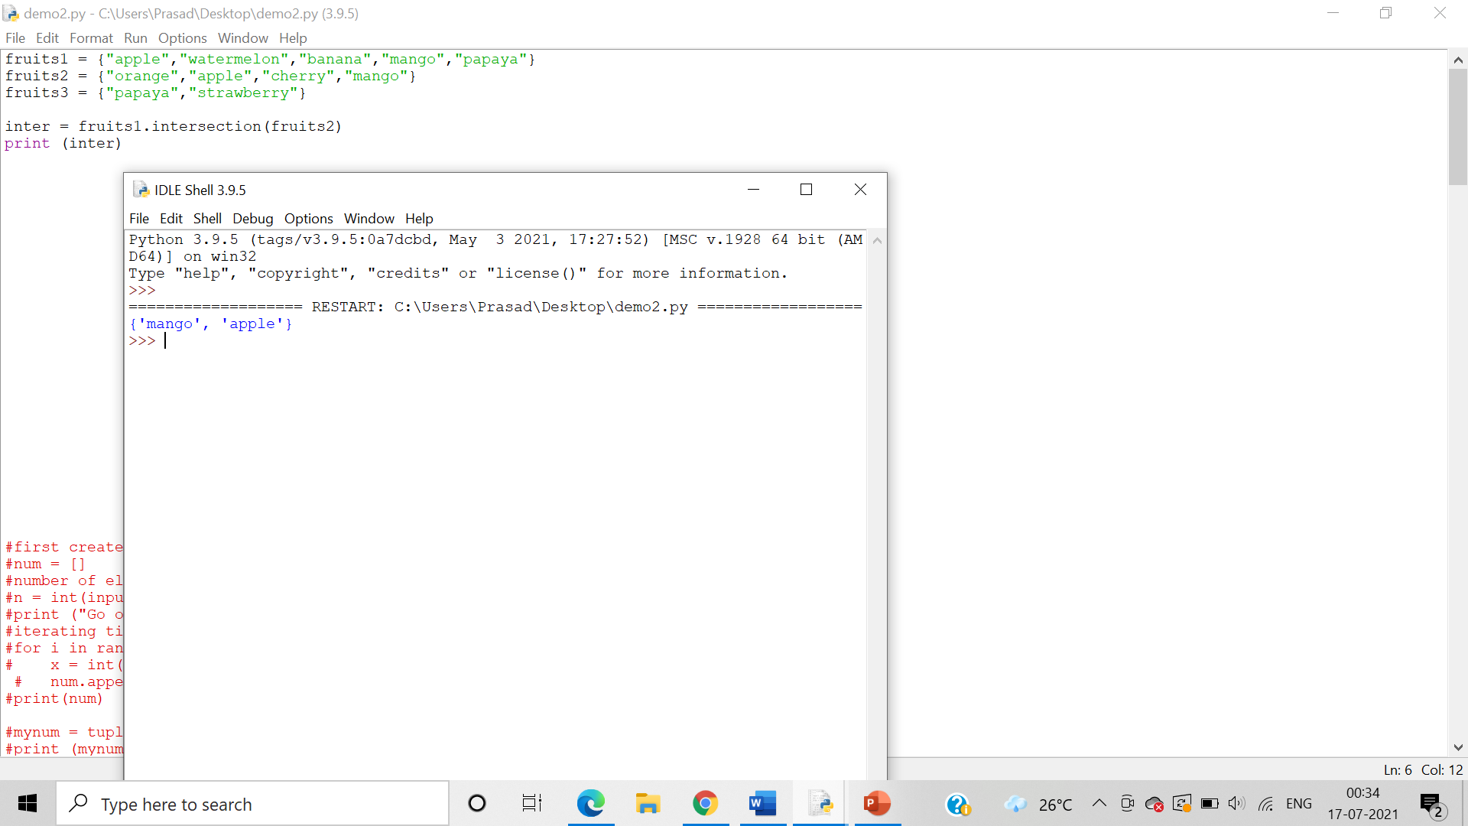

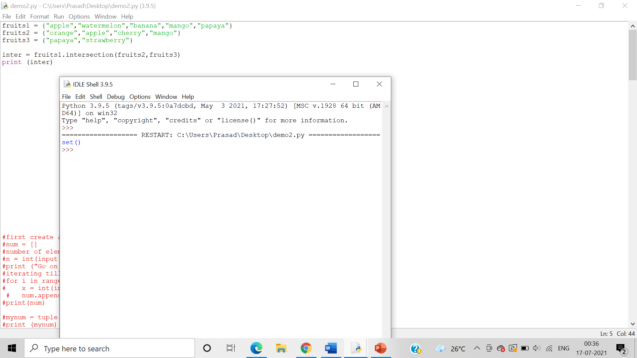

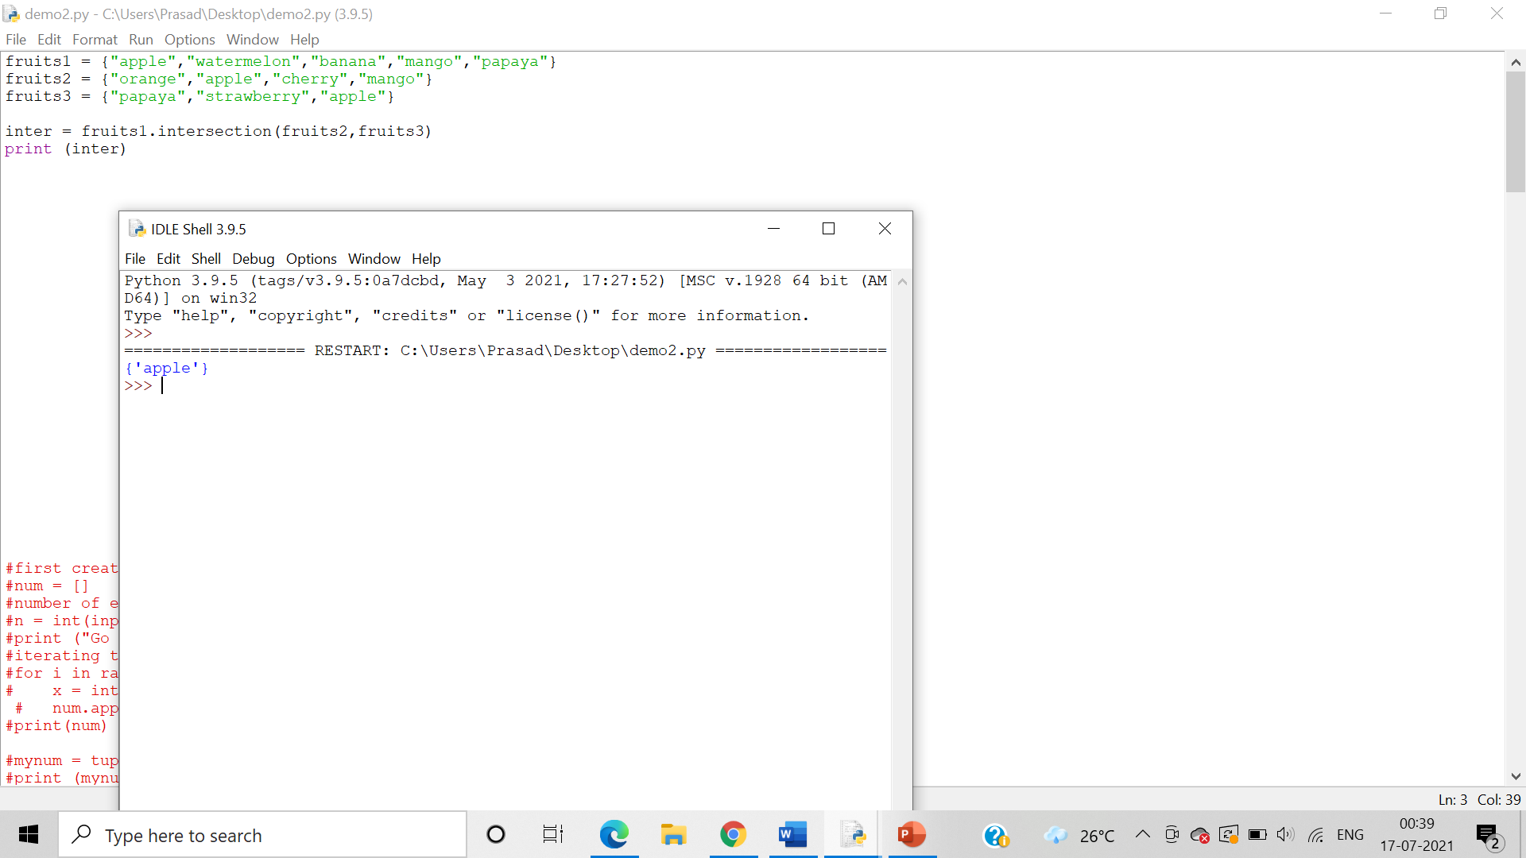

Program for demonstrating intersection_update()

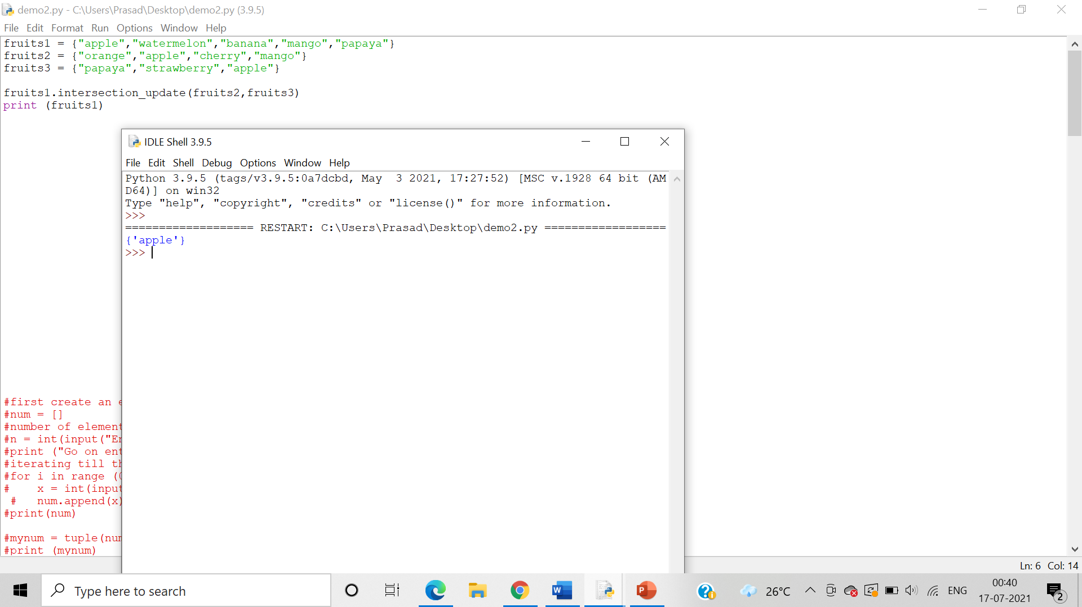

Program for demonstrating isdisjoint()

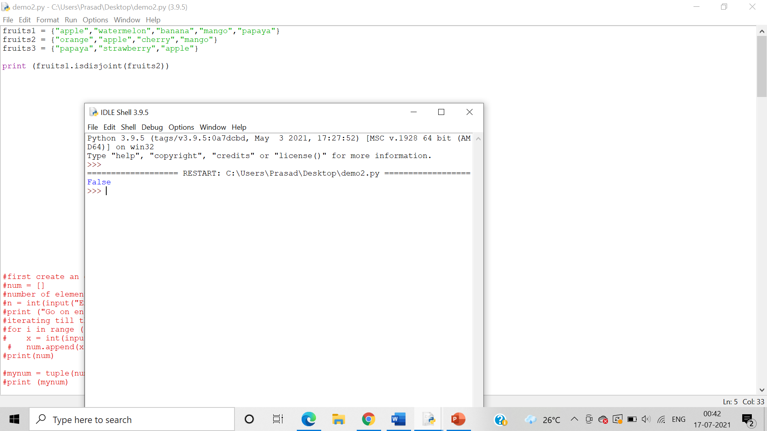

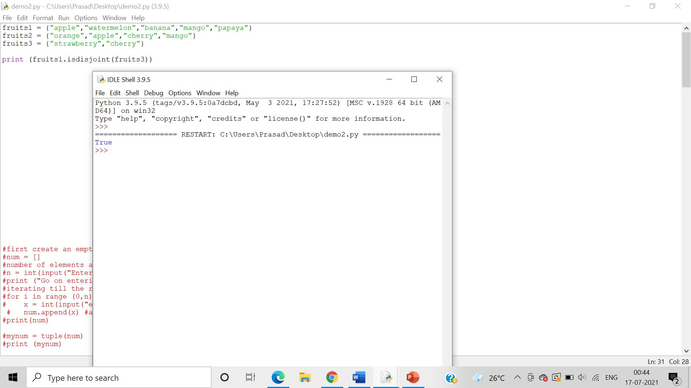

Program for demonstrating issubset()

Algorithm:-

Step 1:- issubset() methods returns whether another set contains this set or not.

Step 2:- issuperset() method returns whether this set contains another set or not.

Step3:- pop() method removes an element from the set.

Step 4:- remove() method removes the specified element.

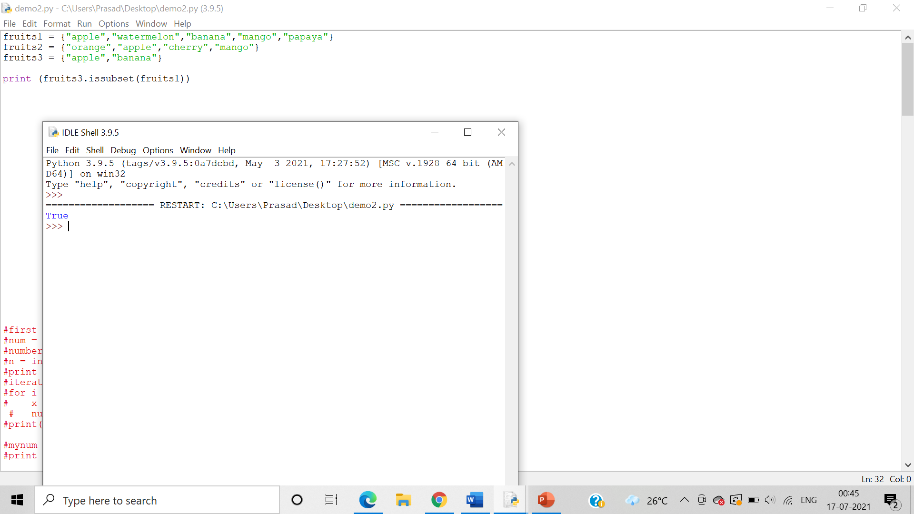

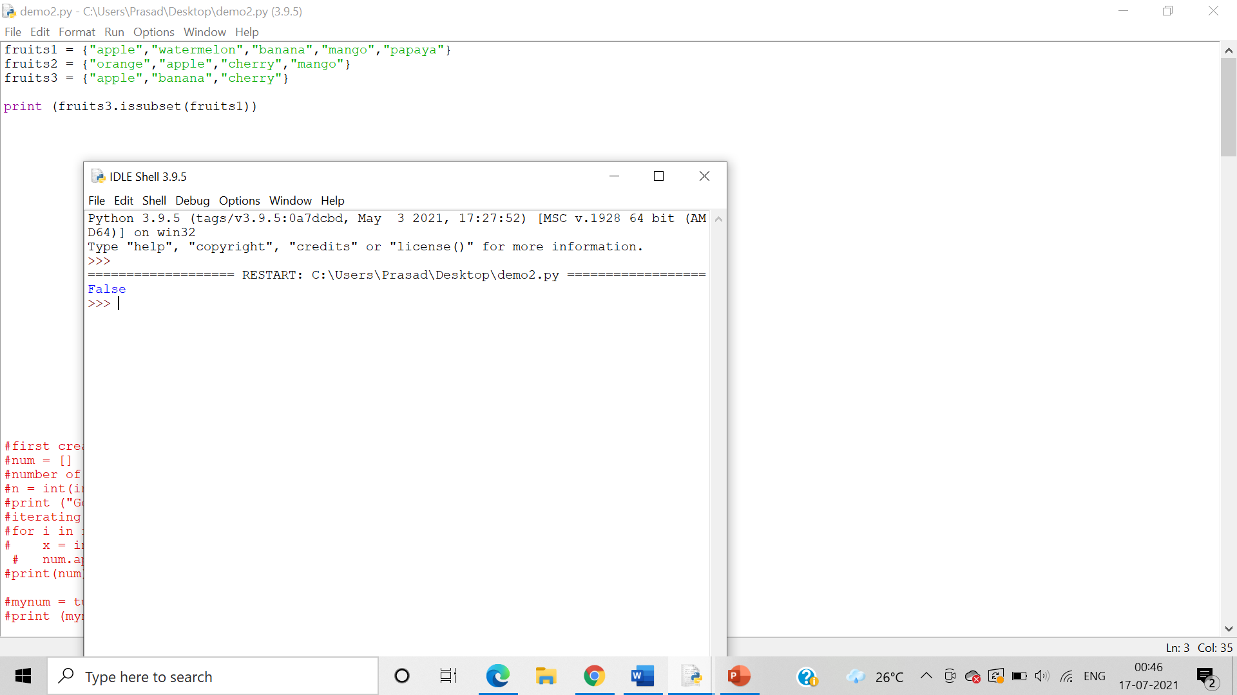

Program for demonstrating issuperset()

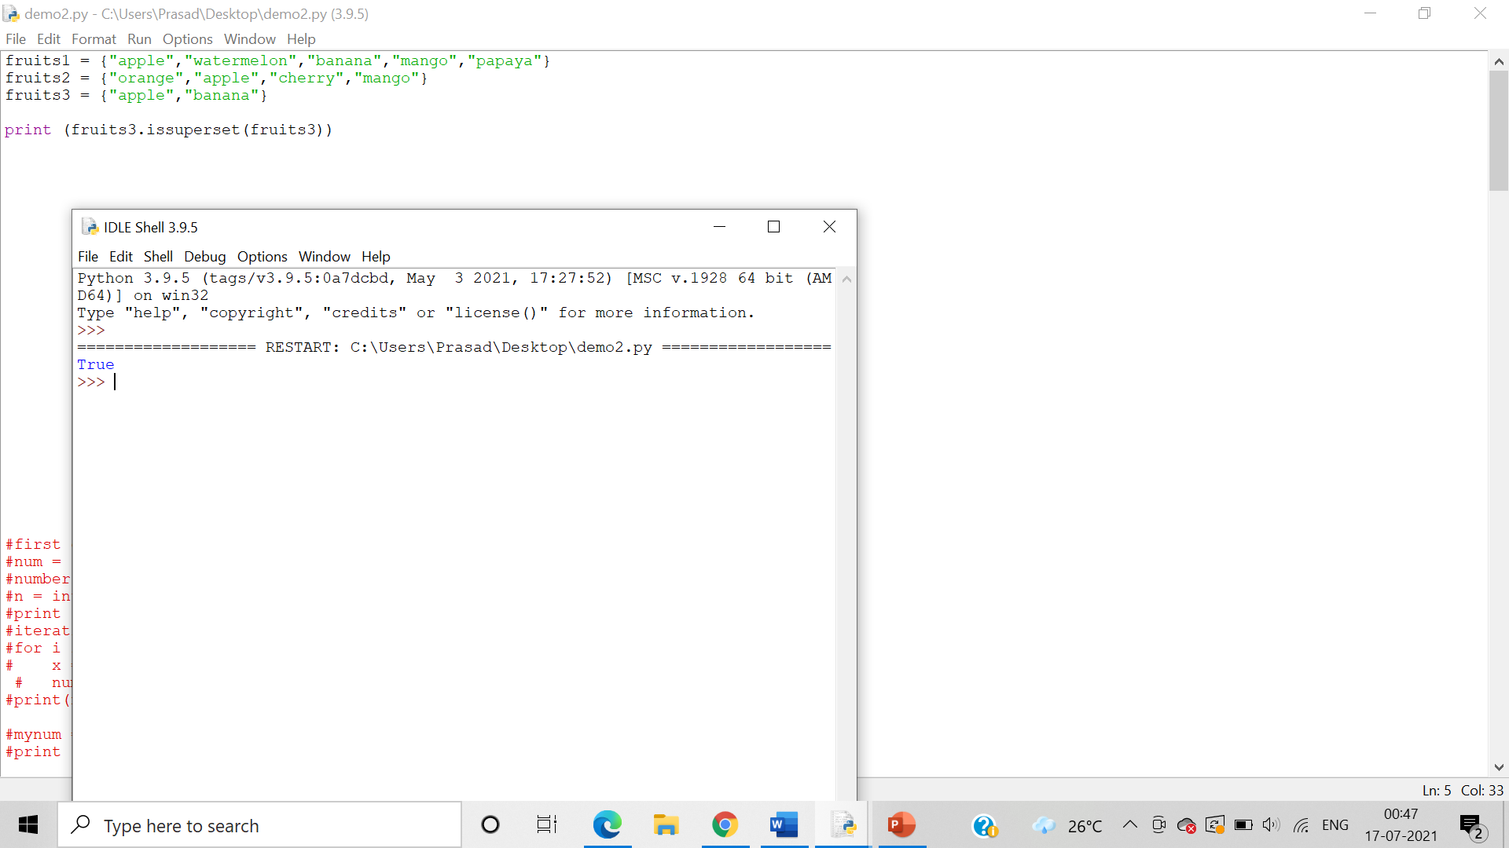

Program for demonstrating symmertic_difference()

Algorithm:-

Step 1:- symmetric_difference() method returns a set with the symmetric differences of two sets.

Step 2:- symmetric_difference_update() method inserts the symmetric differences from this set and another.

Step3:- union() method return a set containing the union of sets .

Step 4:-update() method update the set with the union of this set and others.

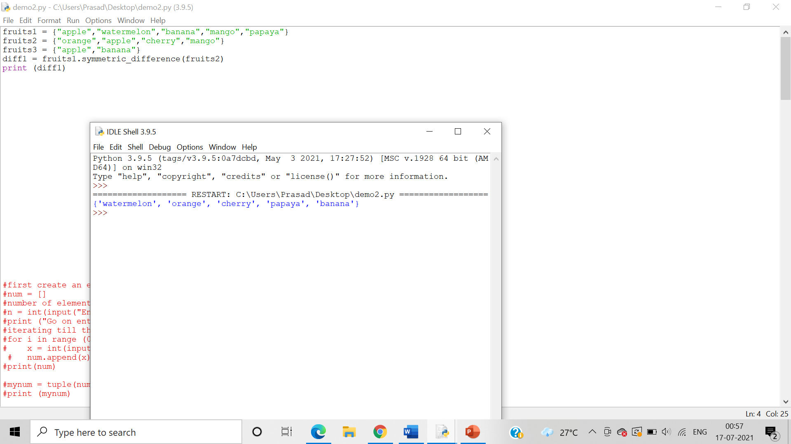

Program for demonstrating symmertic_difference_update()

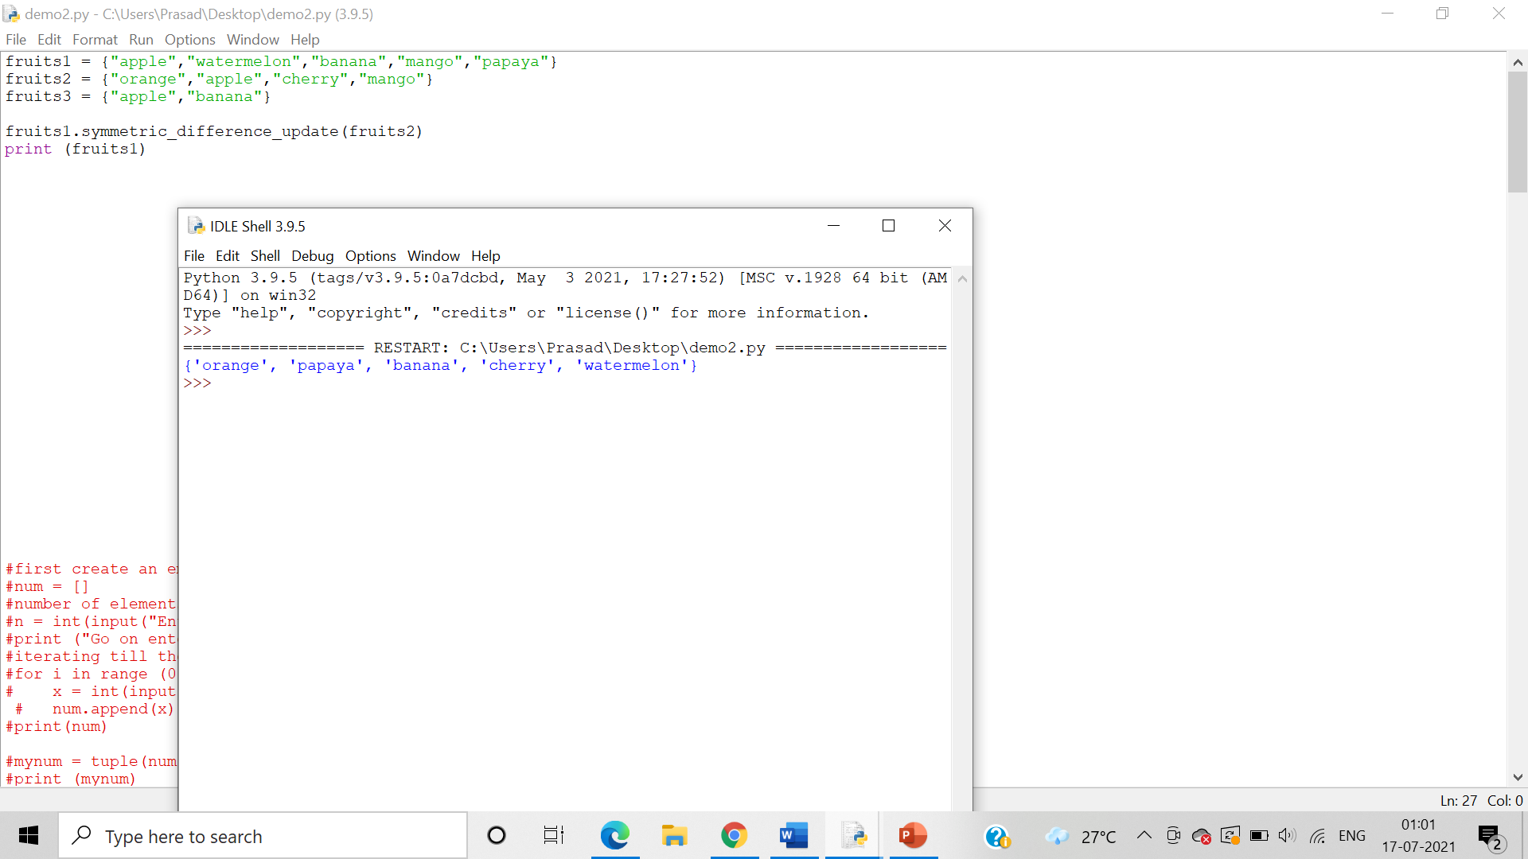

Program for demonstrating union()

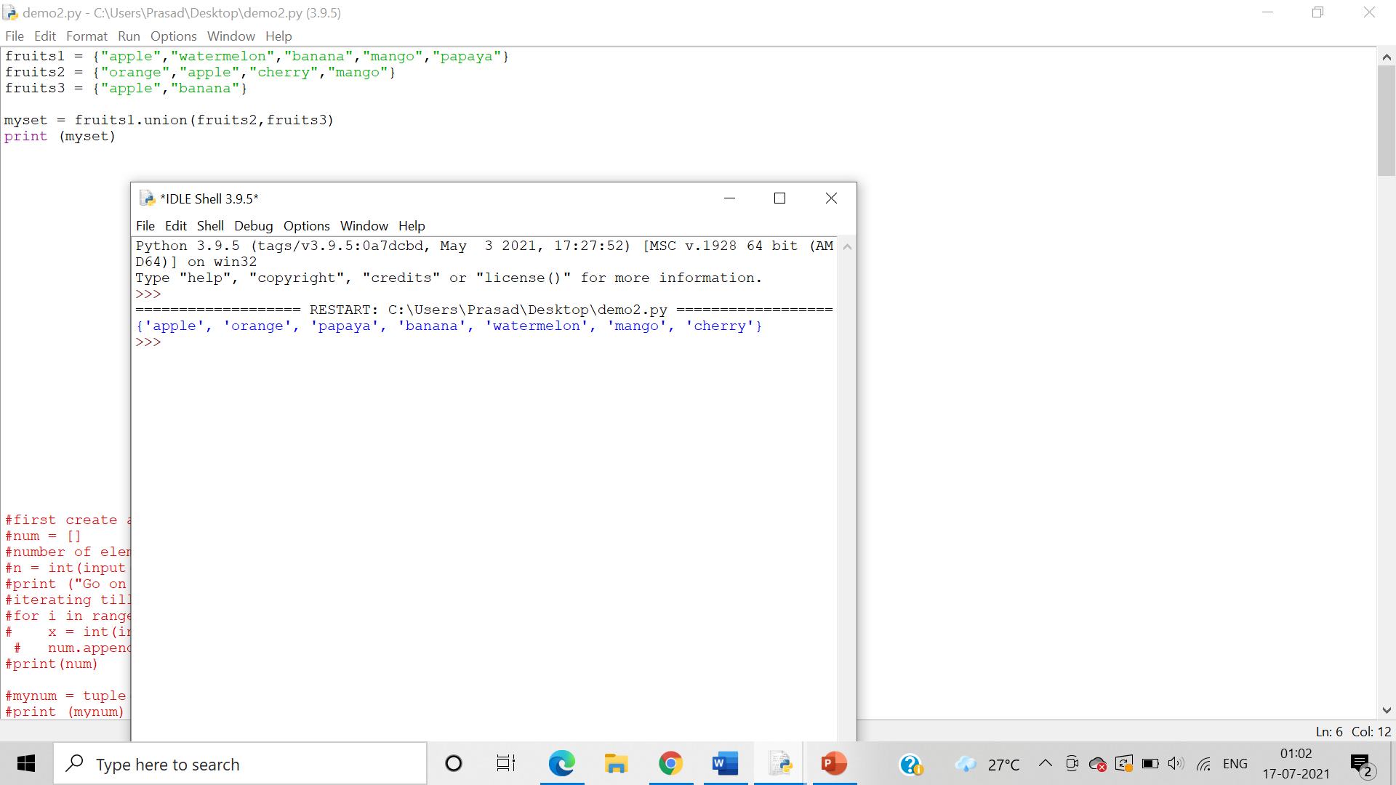

Program for demonstrating update()

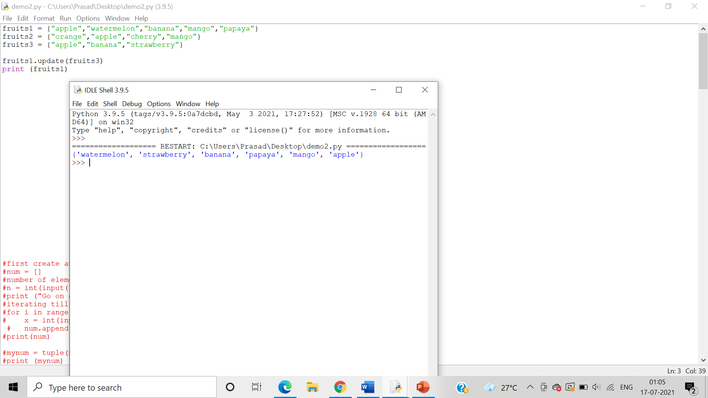

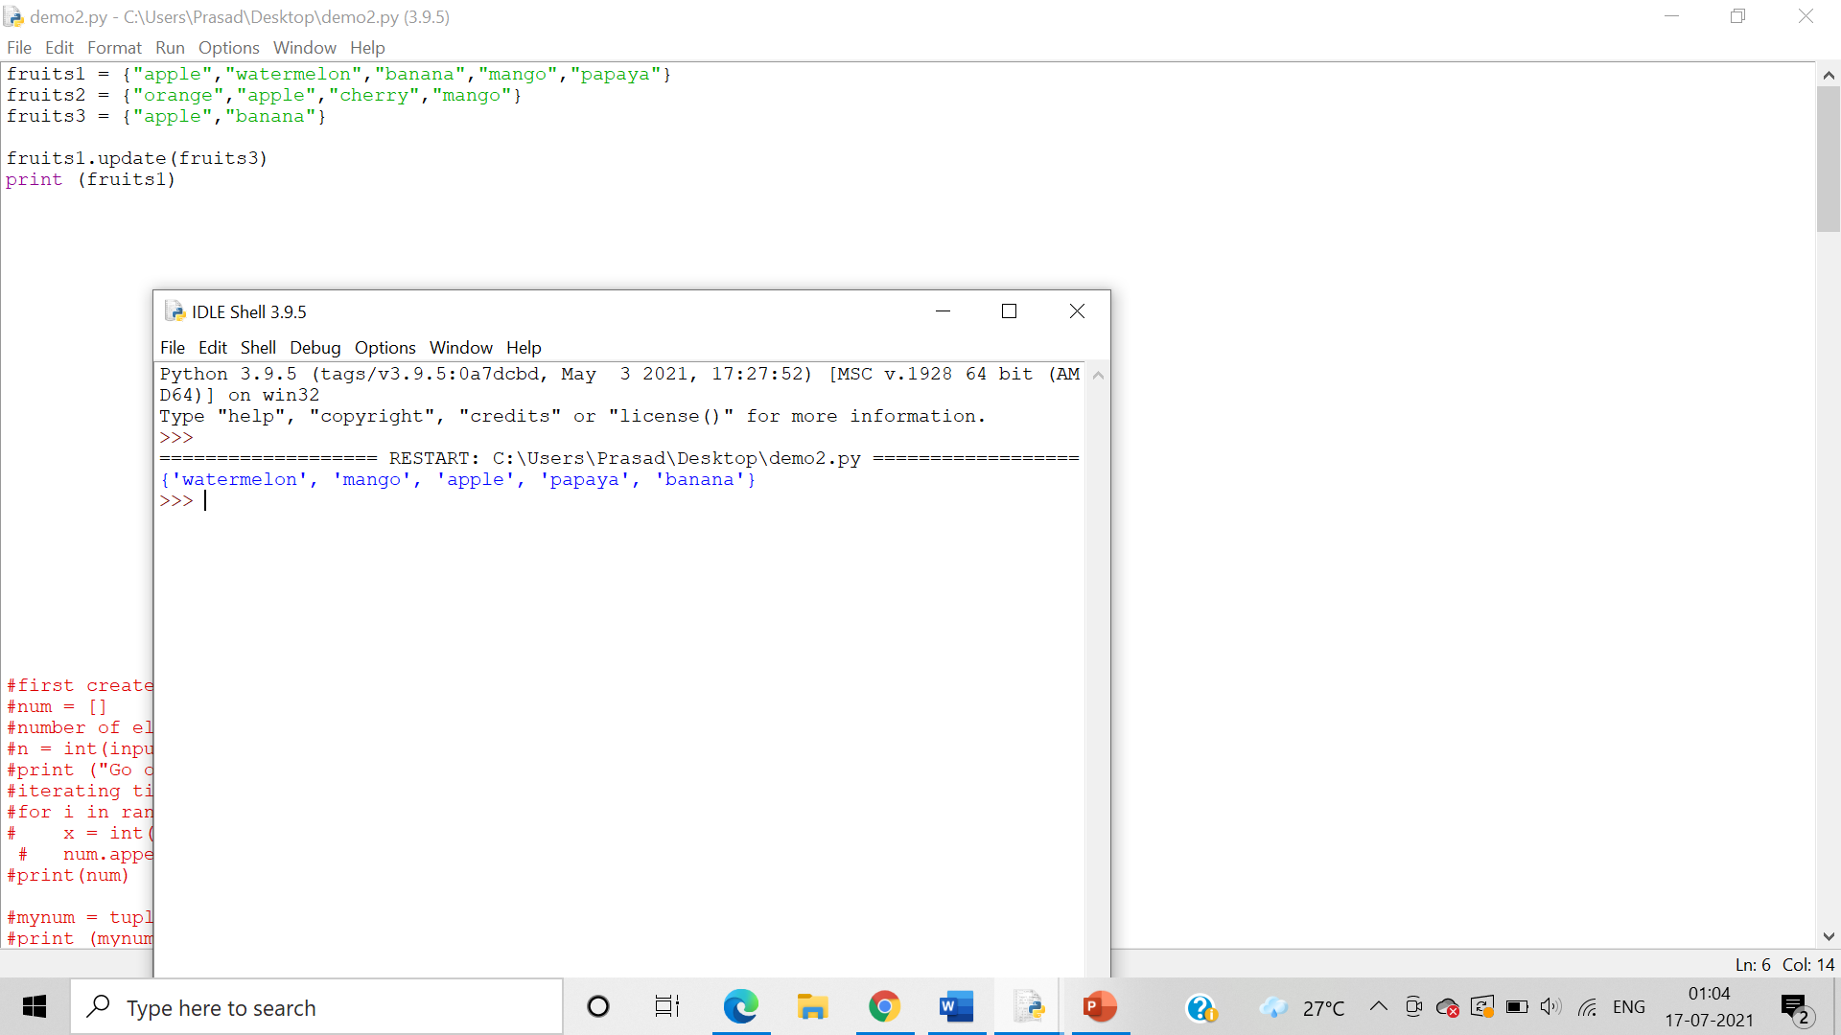

5. Demonstrate declaration and usage of frozen sets

Algorithm:-

Step 1:- A set is created by placing all the items (elements) inside curly braces {}, separated by comma, or by using the built-in set() function.

Step 2:- A frozen set is created by using the frozenset() method.

Step3:- If no parameters are passed, it returns an empty frozenset.

Answer: Program for declaration and usage of frozen sets

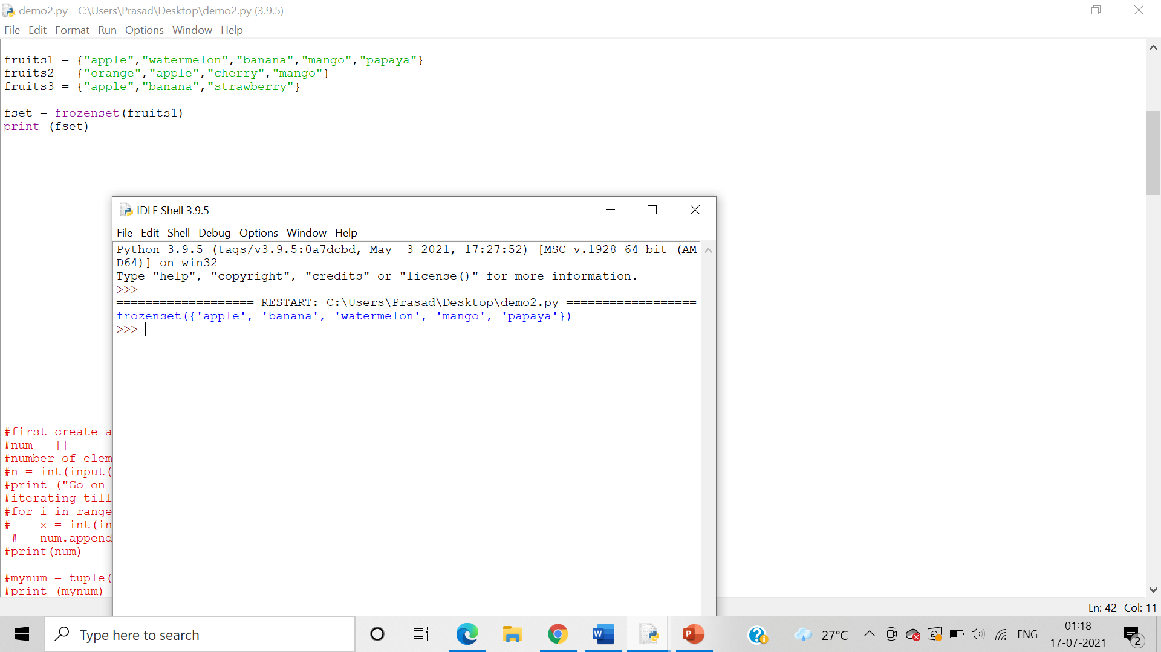

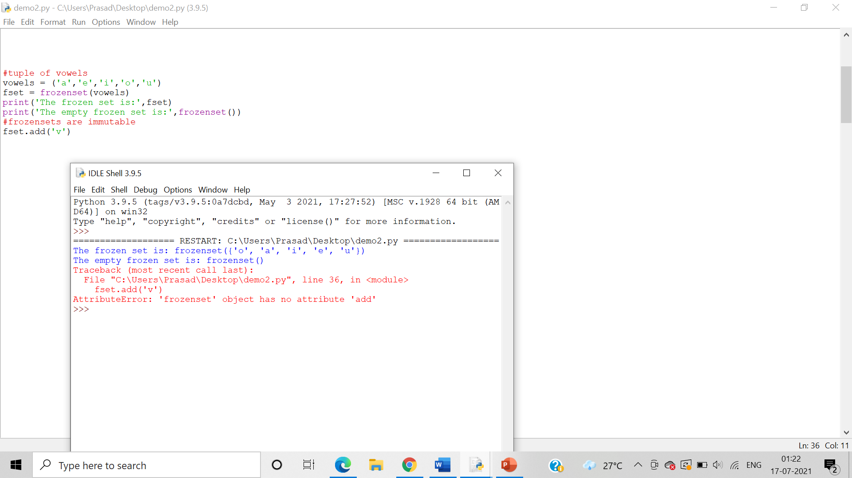

6. Write a program demonstrating declaration and accessing dictionaries and its elements.

Algorithm:-

Step 1:- A set is created by placing all the items (elements) inside curly braces {}, separated by comma, or by using the built-in set() function. You can declare a set by assigning it to a variable.

Step 2:-You can access the set by using the key in a square bracket ‘[]’.

Answer: Program demonstrating accessing dictionaries and its elements:

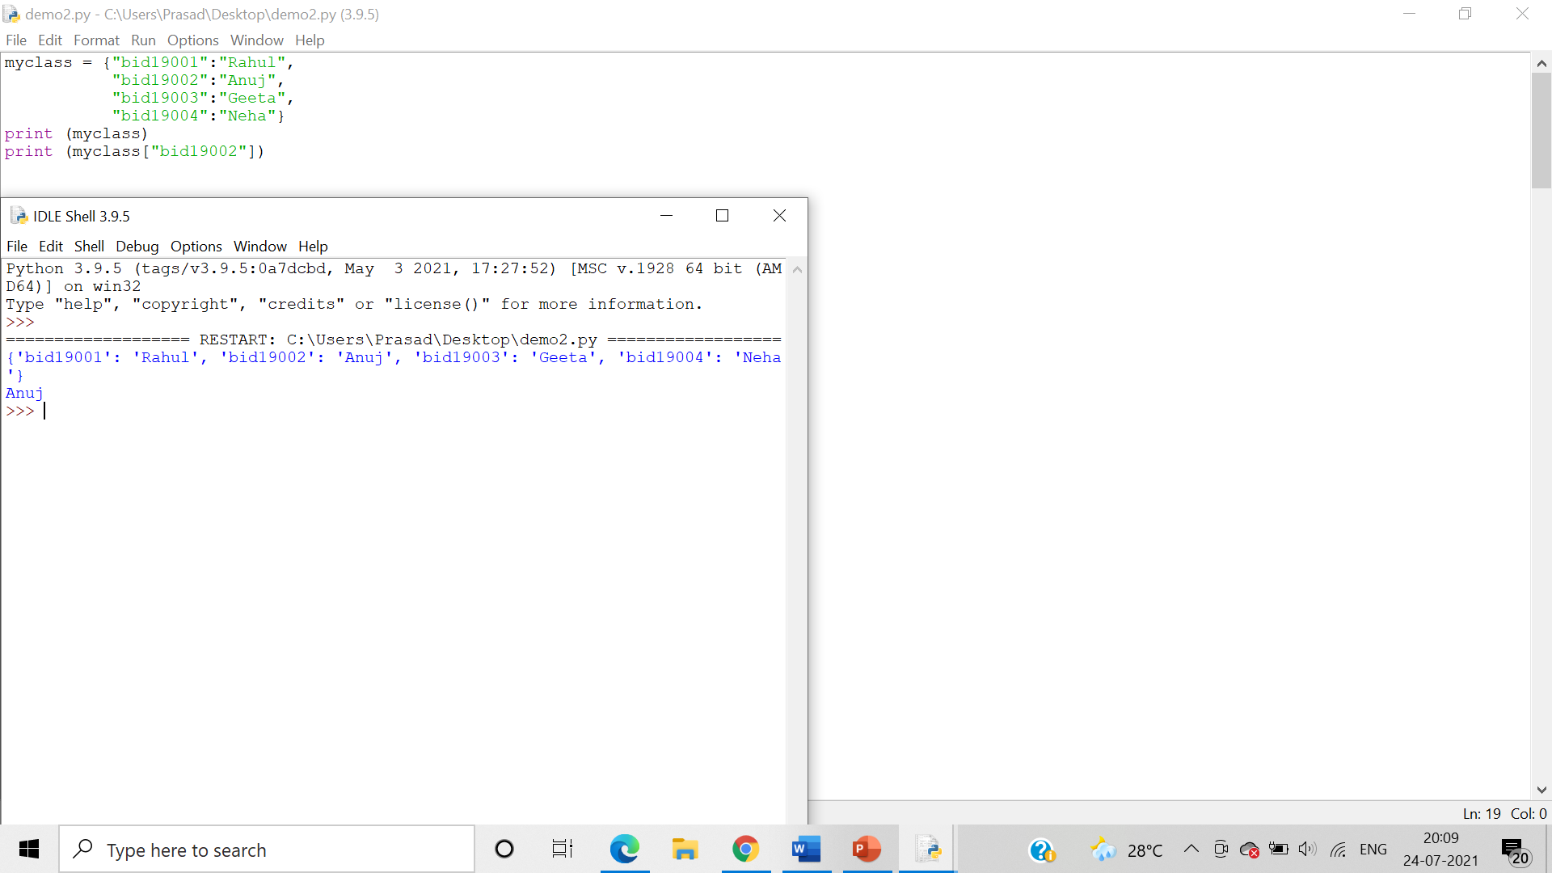

7. Write a program demonstrating looping through the dictionaries, printing keys and values separately and together

Algorithm:-

Step 1:- Using a for loop where x is a key in a set, we can print keys separately by printing ‘x’.

Step 2:- Using a for loop where y is a key in a set, we can print the values separately by printing ‘days[y]’ which will print the value assigned to the key ‘y’.

Step3:- Using a for loop where z is a key in a set, we can print keys and values together by printing ‘z’ which will print the keys and days[‘z’],which will print the value assigned to the key ‘z’.

Answer: Program demonstrating looping through the dictionaries

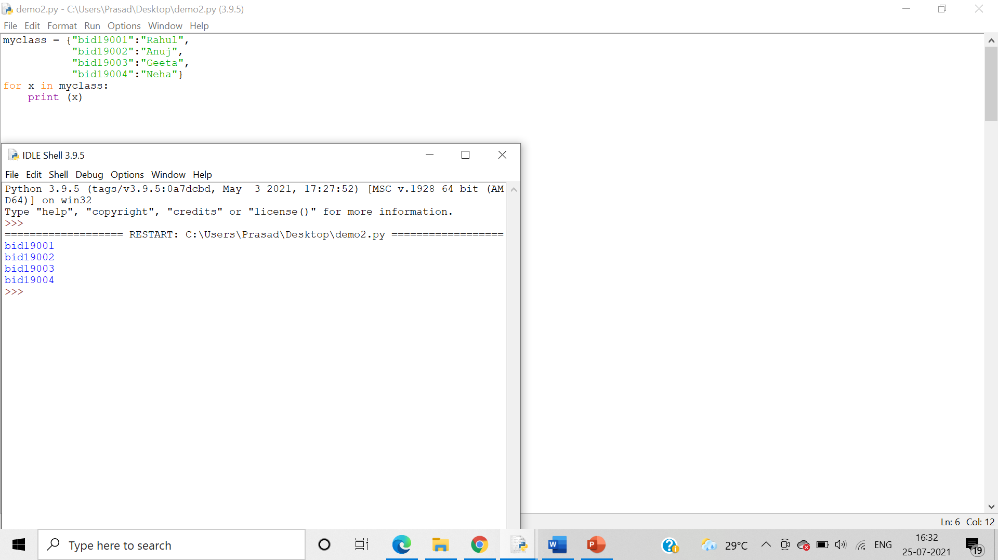

Program demonstrating looping through the printing values:

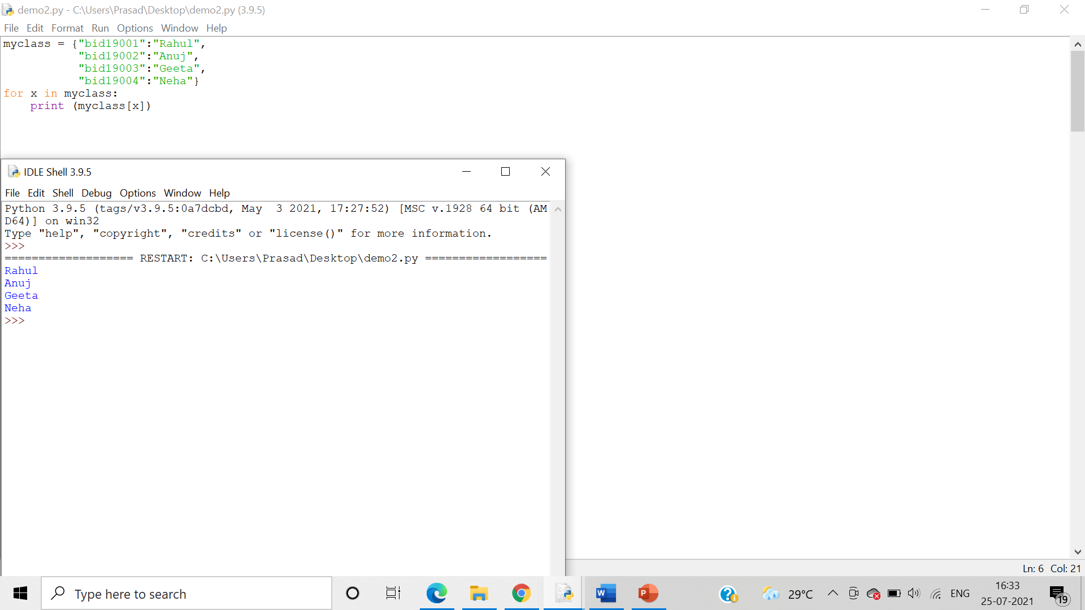

Program demonstrating looping through the printing values and keys:

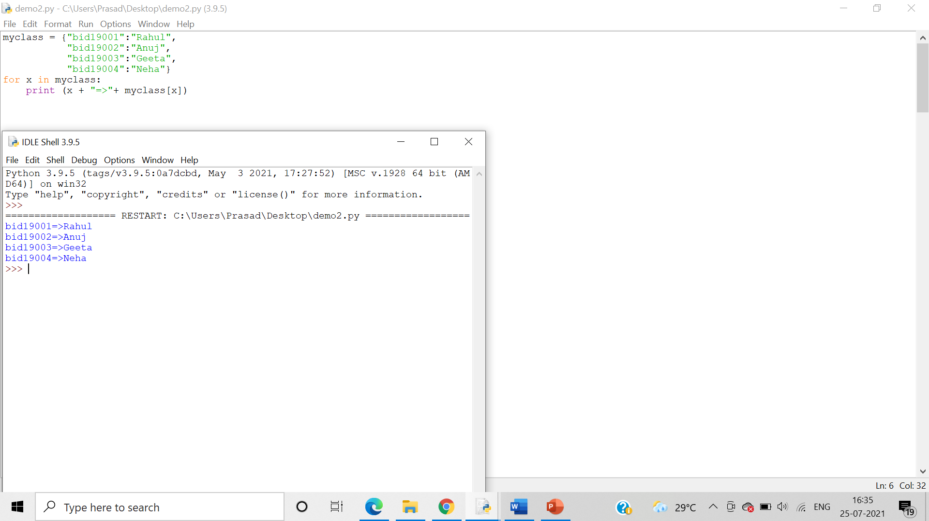

8. Write a program demonstrating “in” and “not in” keywords on Dictionaries

Algorithm:-

Step 1: - The ‘in’ operator is used to **check if an element is present** in the dictionary or n not. Returns true if element is present in dictionary else returns false.

Step 2:  The ‘not in’ operator is used to **check if an element is not present** in the

dictionary or not. Returns true if element is not present in dictionary else returns false.

Answer: A program demonstrating “in” keyword on Dictionaries: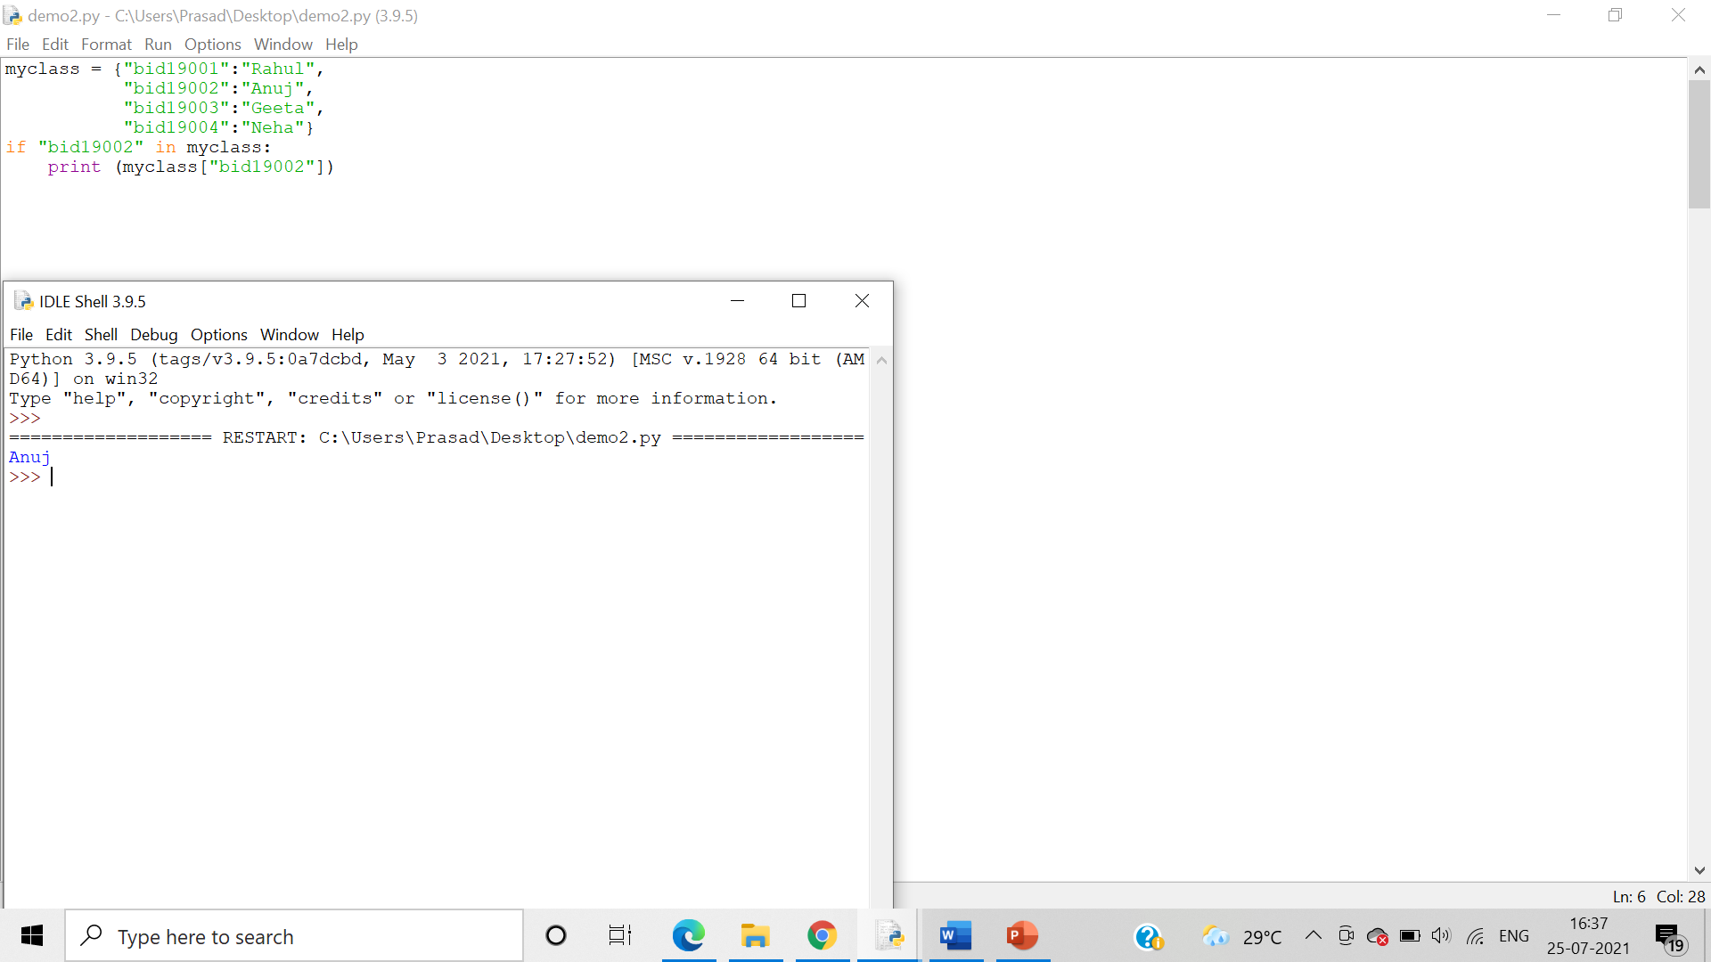

A program demonstrating “not in” keyword on Dictionaries

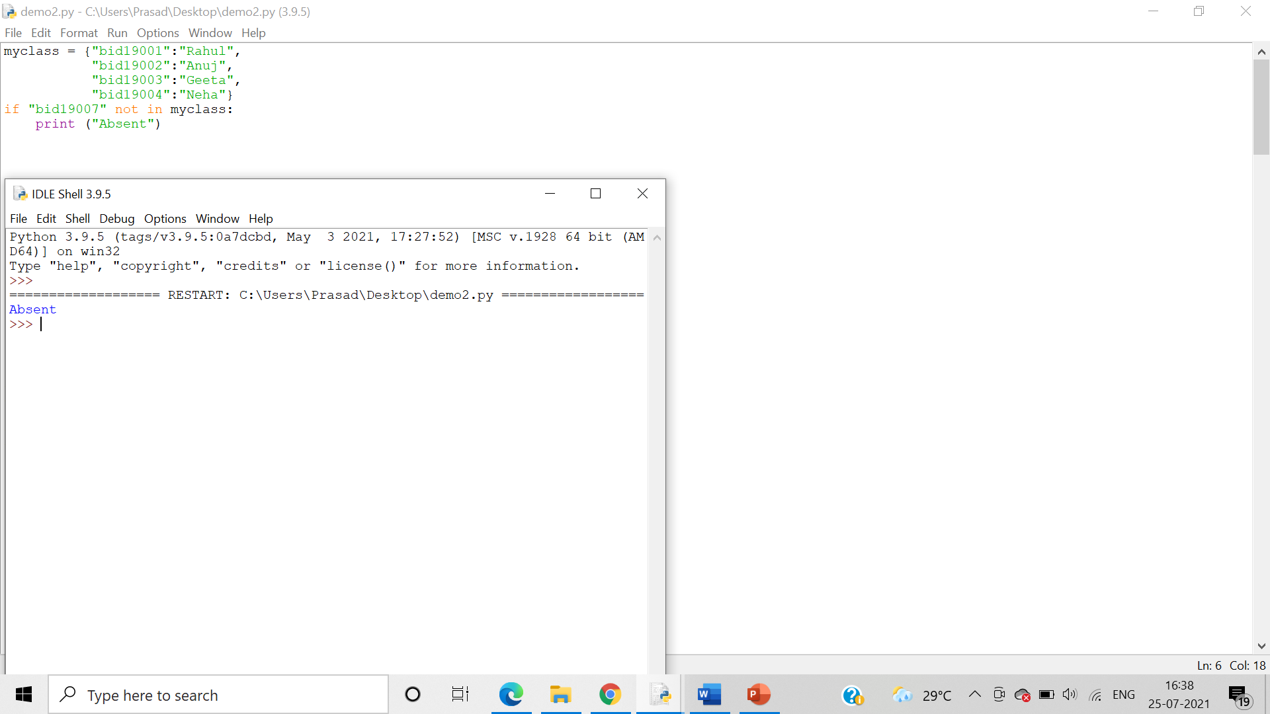

9.Write a program demonstrating len() and del() function on Dictionaries.

Algorithm:-

Step 1:   The len() function is used to obtain the length of the ldictionary

Step 2: The del() function **deletes all the elements in range** starting from index ‘a’ till /////‘b’ mentioned in arguments.

Answer: Program demonstrating len() function on Dictionaries:

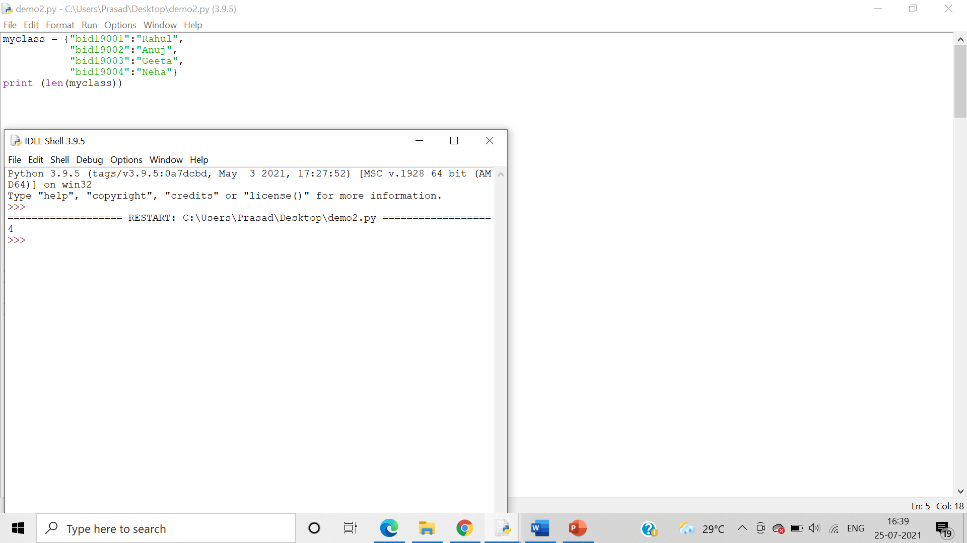

Program demonstrating del() function on Dictionaries:

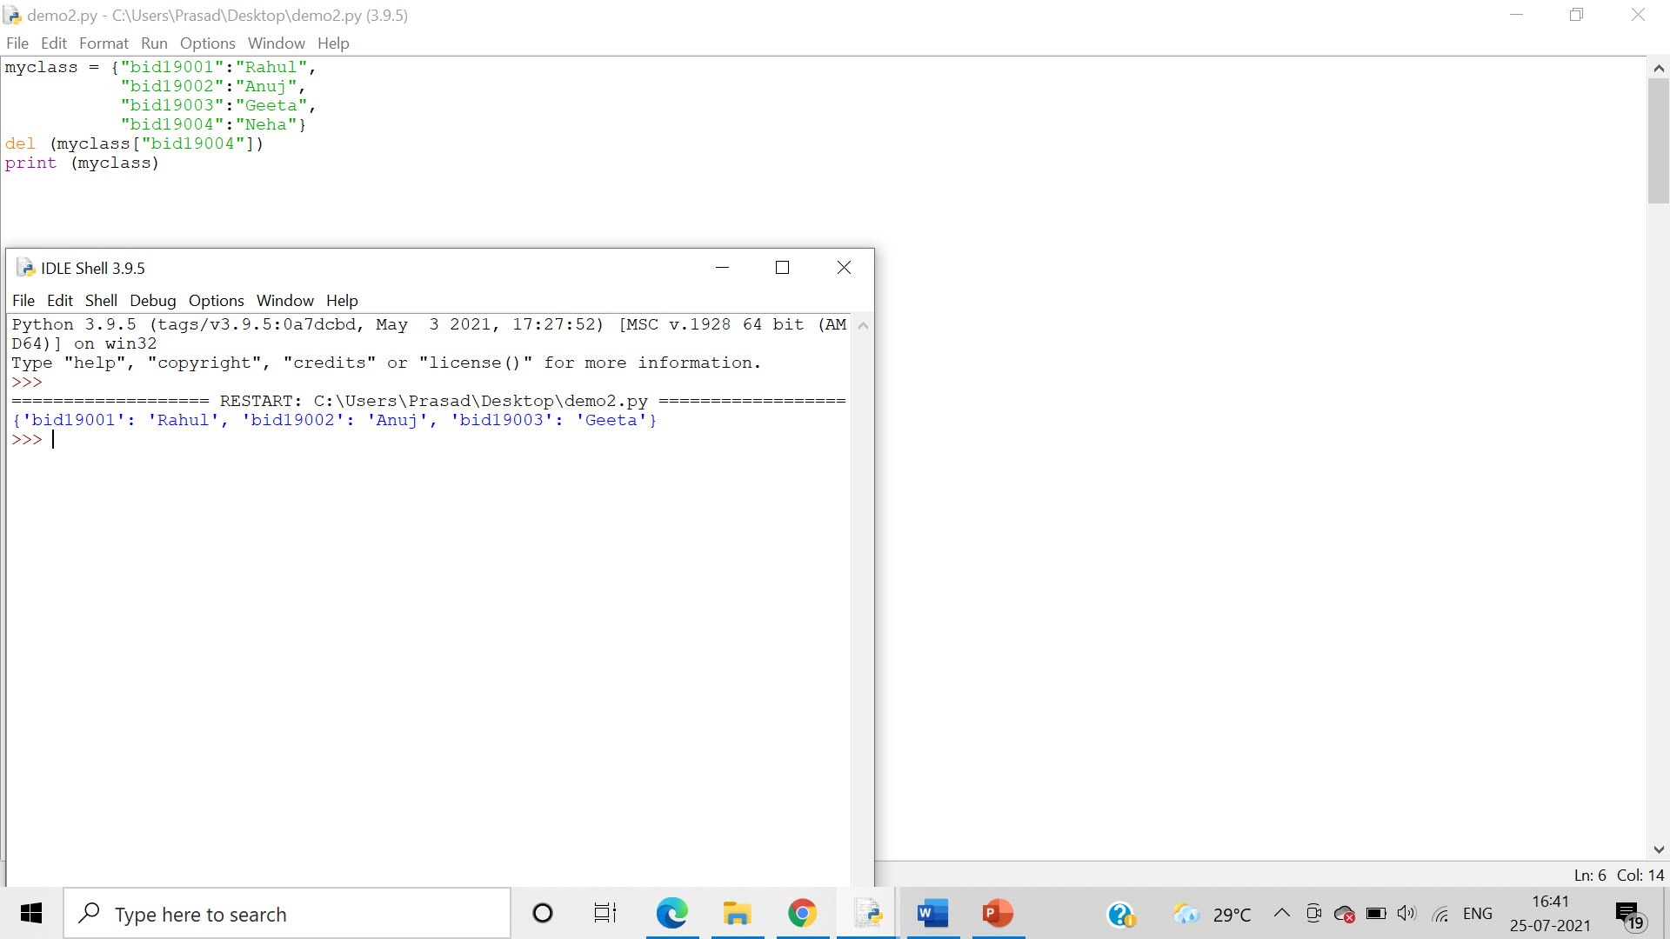

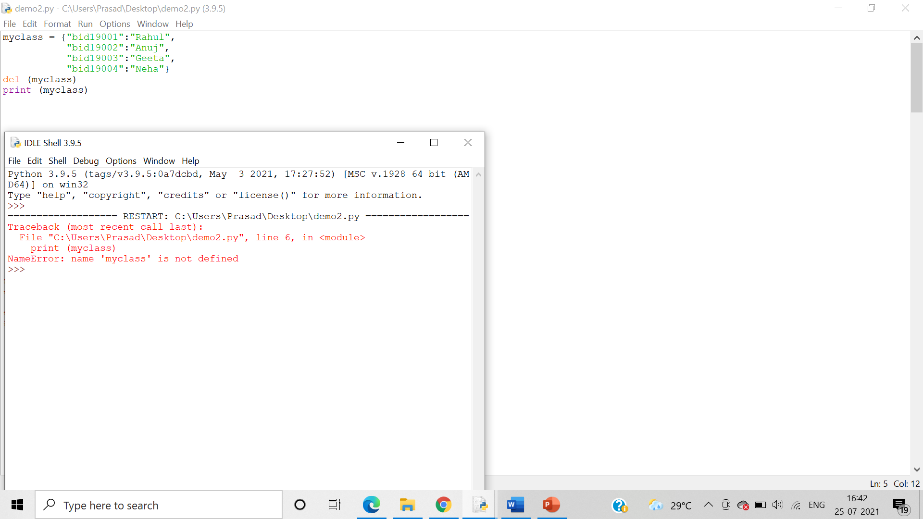

10.Write a program demonstrating Nested Dictionaries

Algorithm:-

Step 1:- In Python, a nested dictionary is a dictionary inside a dictionary. It's a collection of dictionaries into one single dictionary.

Step 2:-Here each key in a dictionary has its own dictionary

Answer: Program demonstrating Nested Dictionaries:

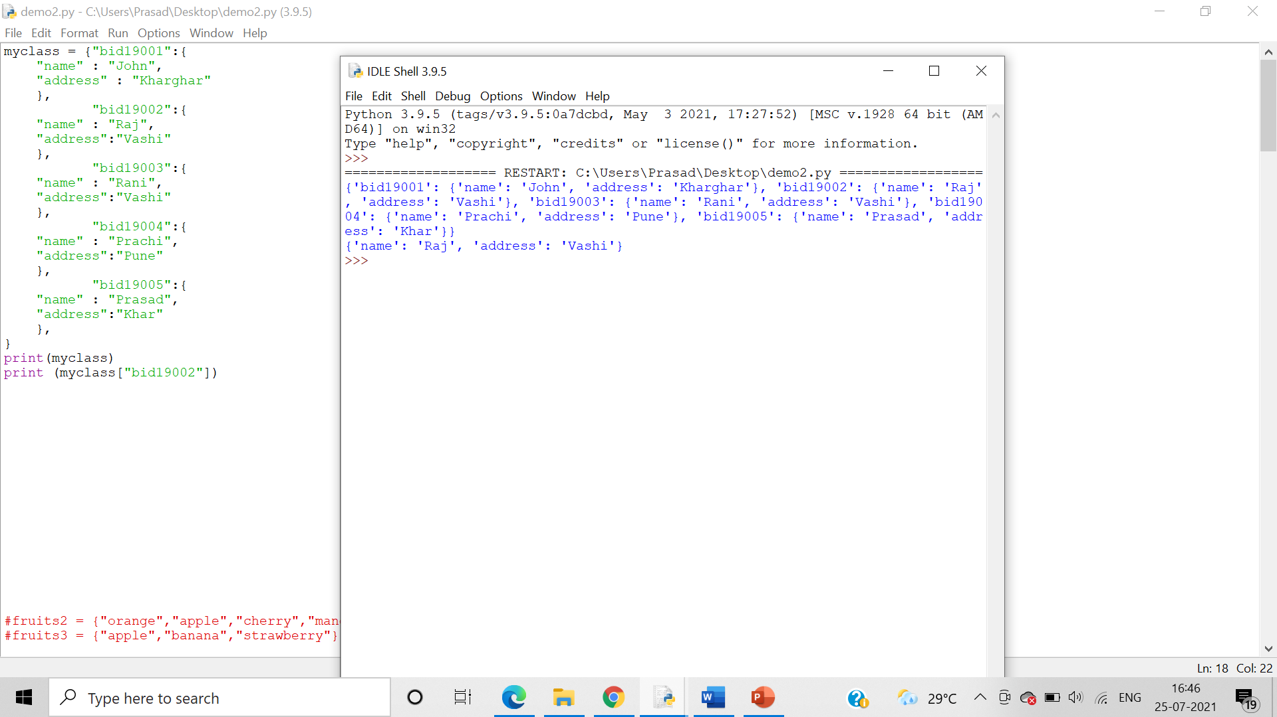

11. Write a program demonstrating input of Dictionary elements from the user

Algorithm:

Step 1:- Take user input for number of elements in the dictionary as well that of both the keys and values in a for loop.

Step 2:- We initialize a empty dictionary to which we can then add the values of both the keys and values using the update() function

Code-Program demonstrating input of Dictionary elements from the user:-

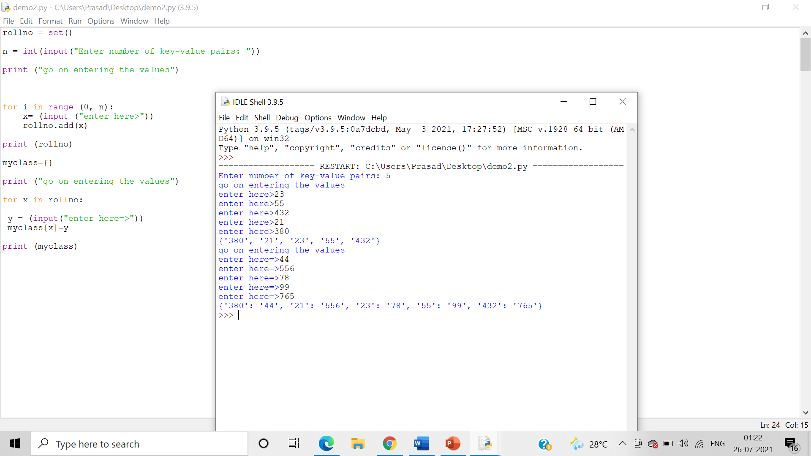

12. Write set of programs for demonstrating the usage of all the different dictionary methods along with their variations

Answer: Programs for demonstrating

Algorithm:-

Step 1:- The clear() method empties the dictionary.

Step 2:- The copy() method returns a copy of the dictionary.

clear()

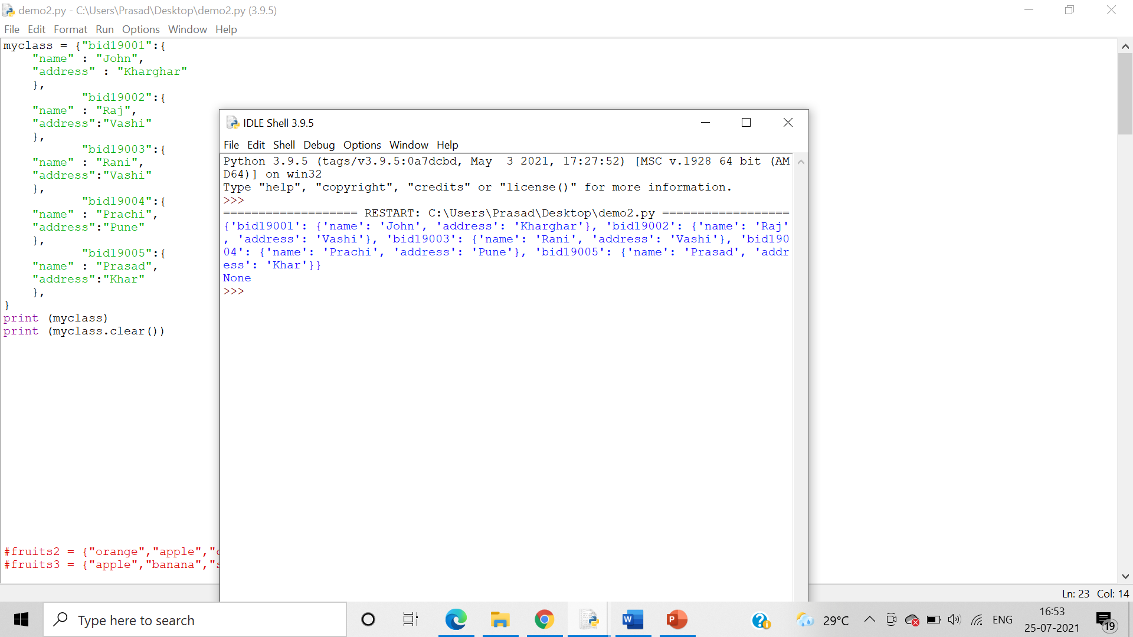

copy()

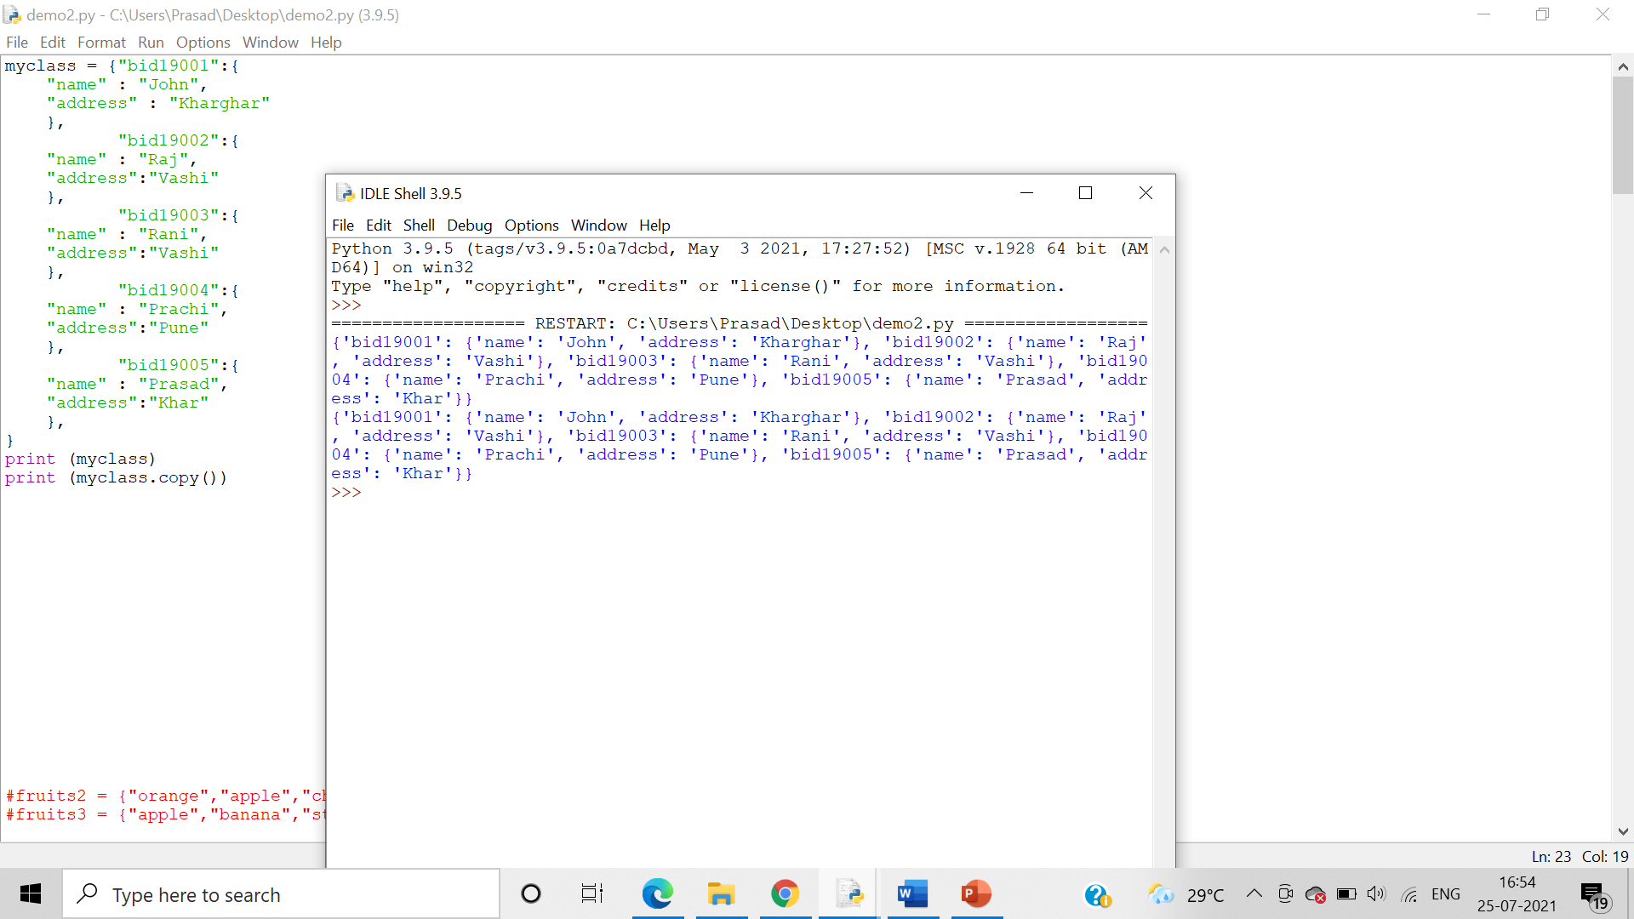

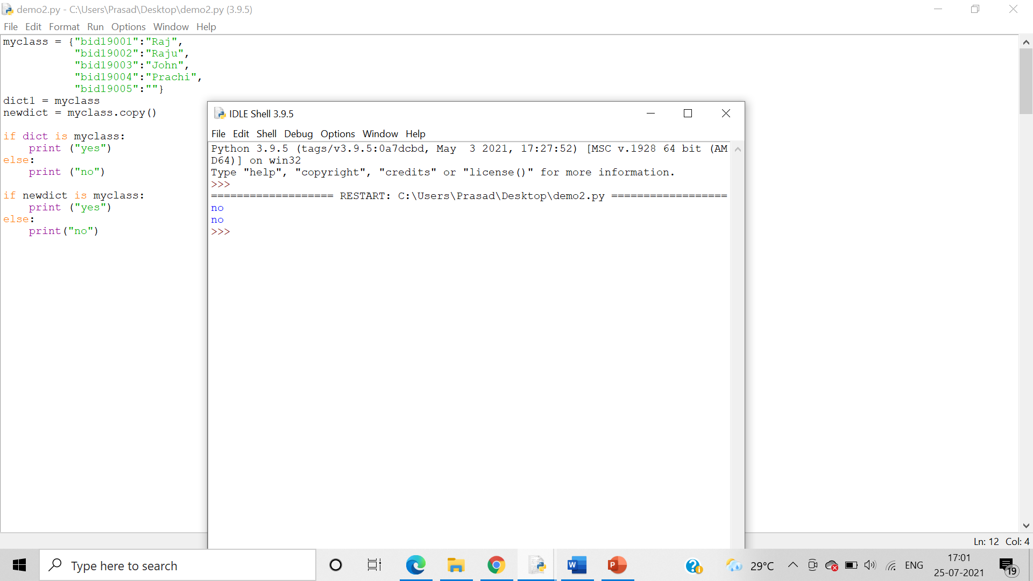

fromkeys()

Algorithm:-

Step 1:- fromkeys() returns a dictionary with the specified keys and value

Step 2:- get() returns the value of the specified key

Step 3:- items() returns a list containing a tuple for each key value pair

Step 4:- keys() returns a list containing the dictionary's keys

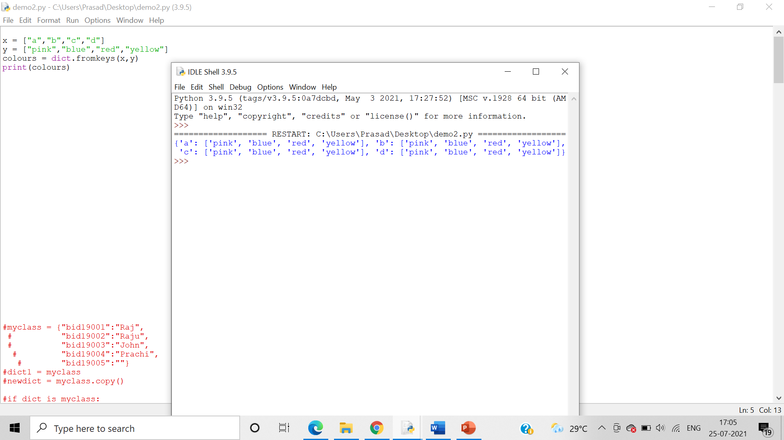

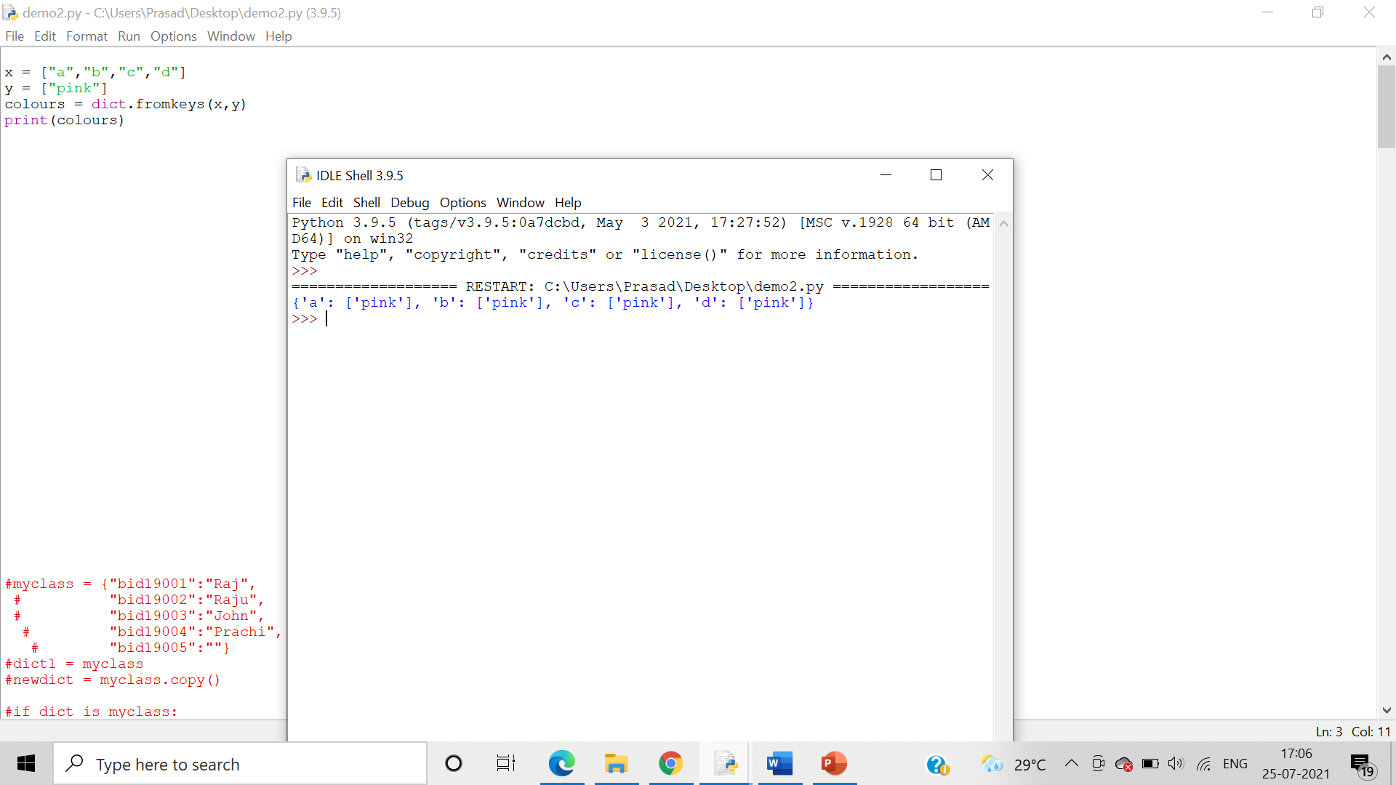

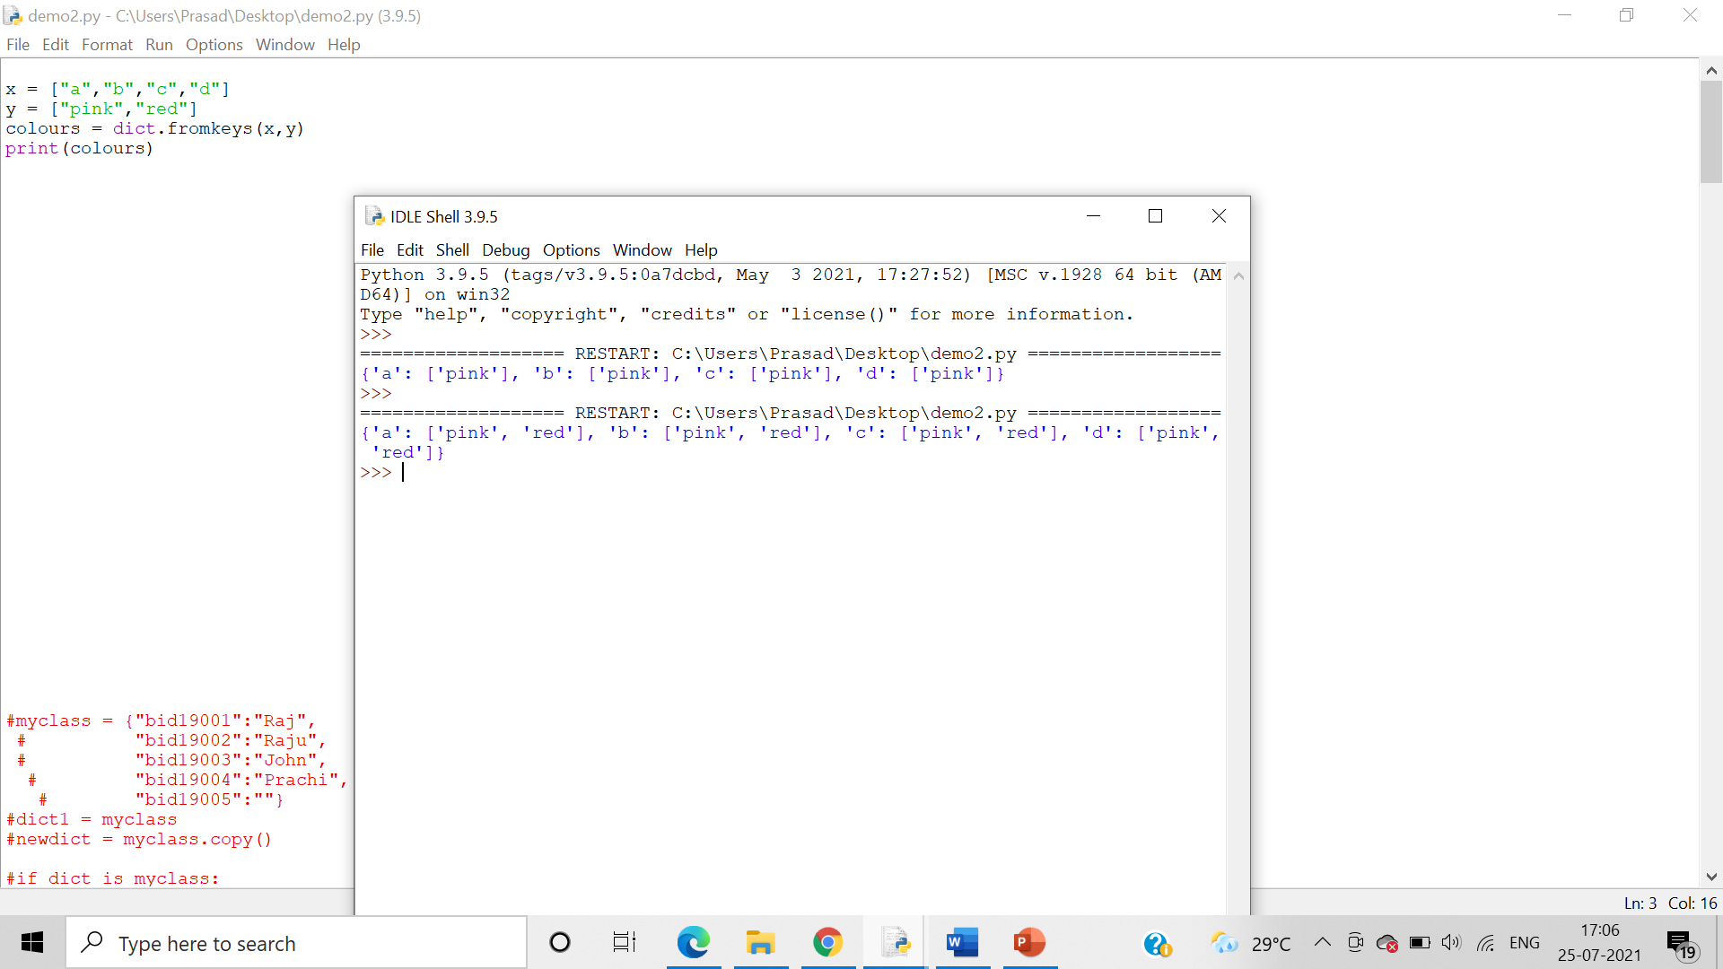

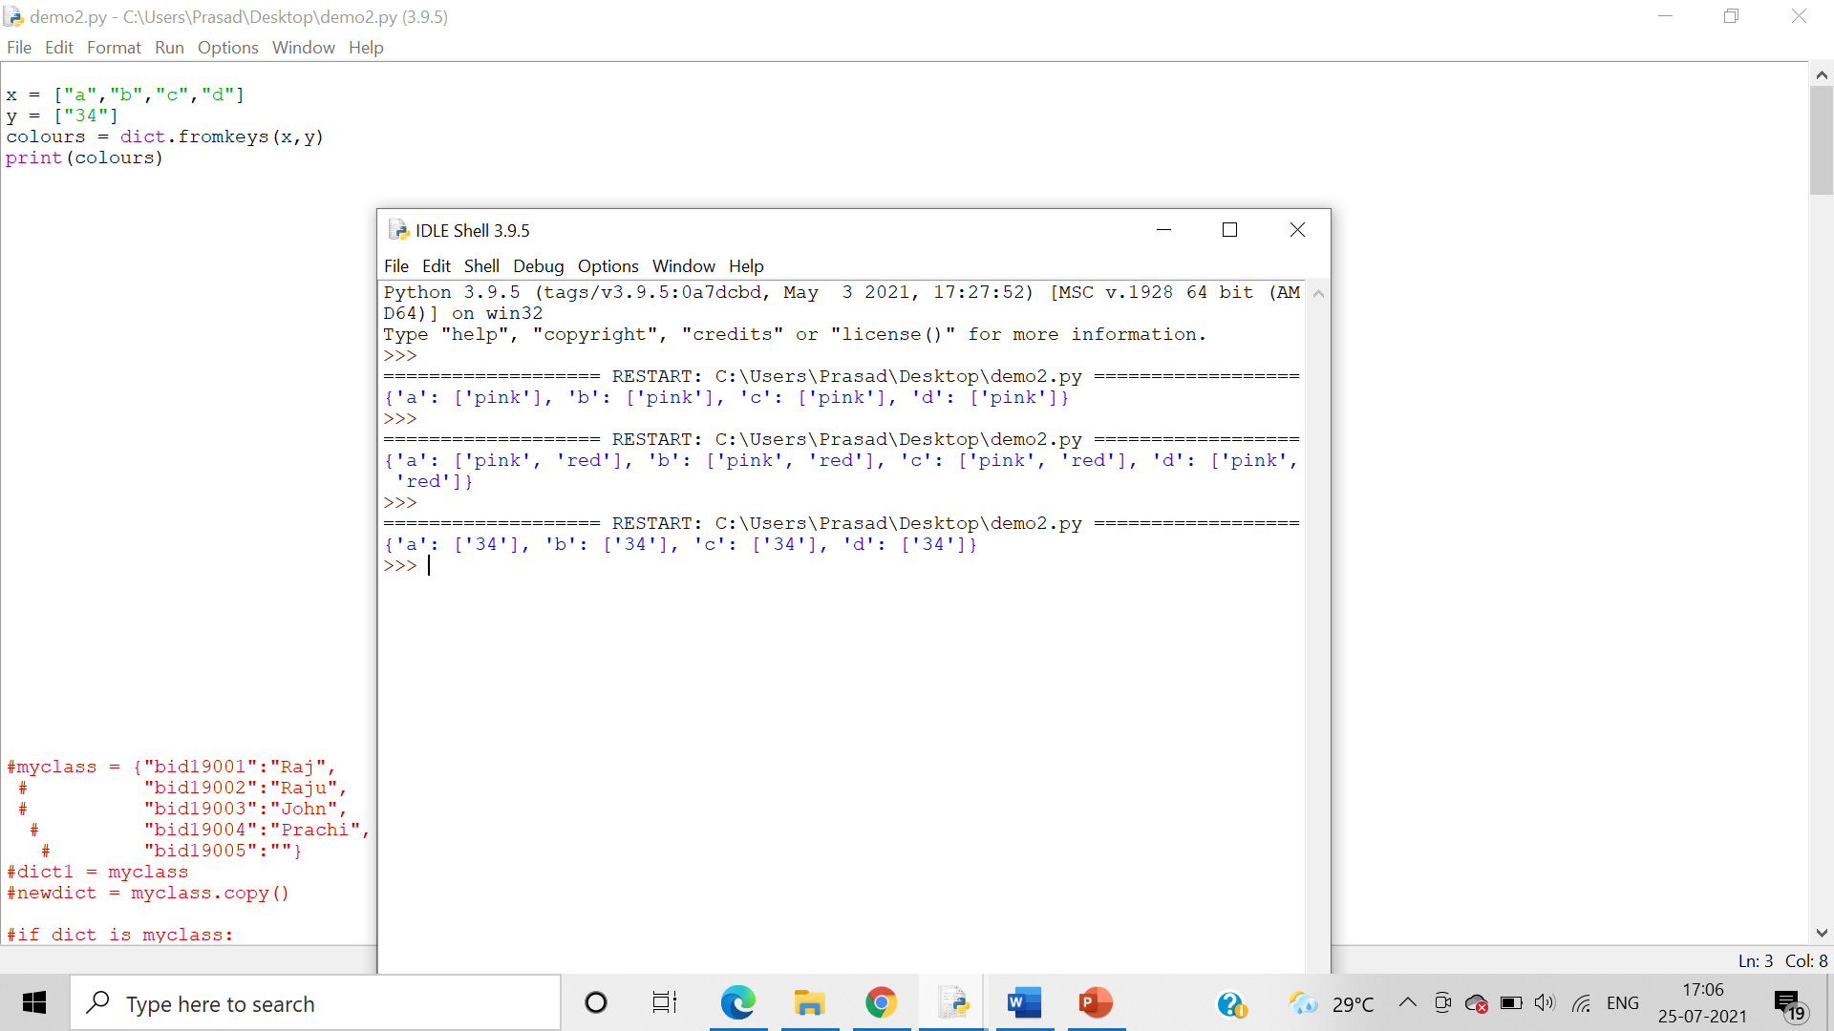

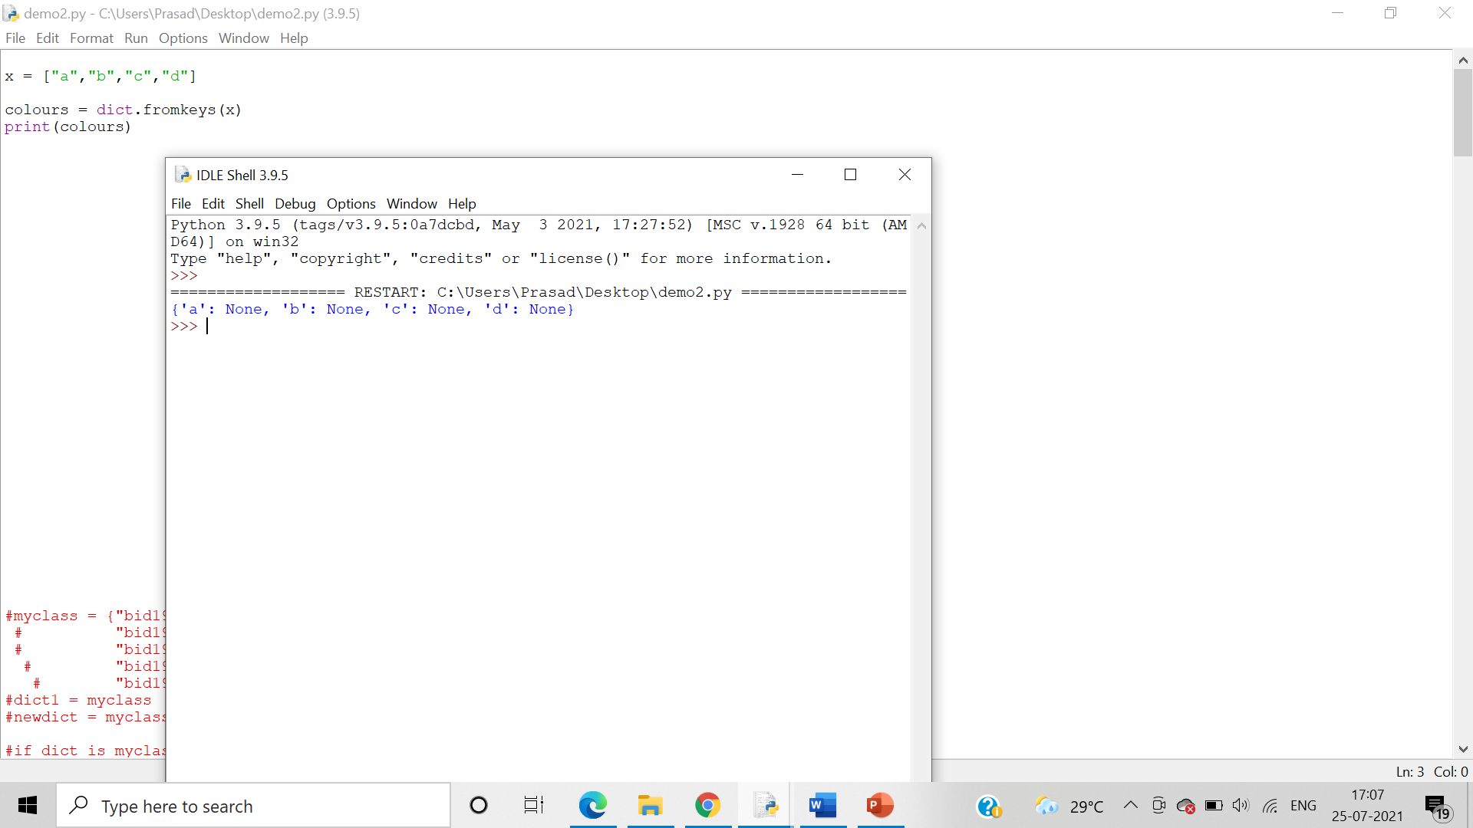

get()

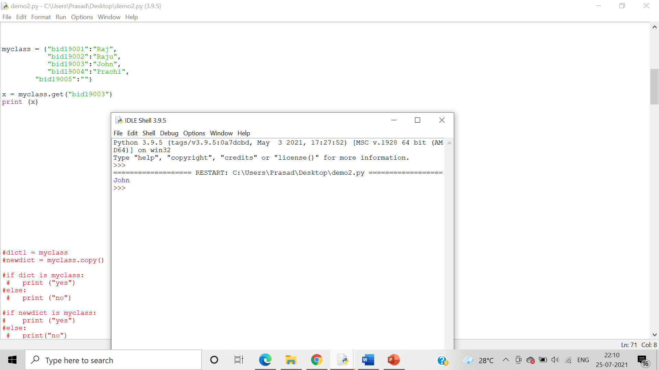

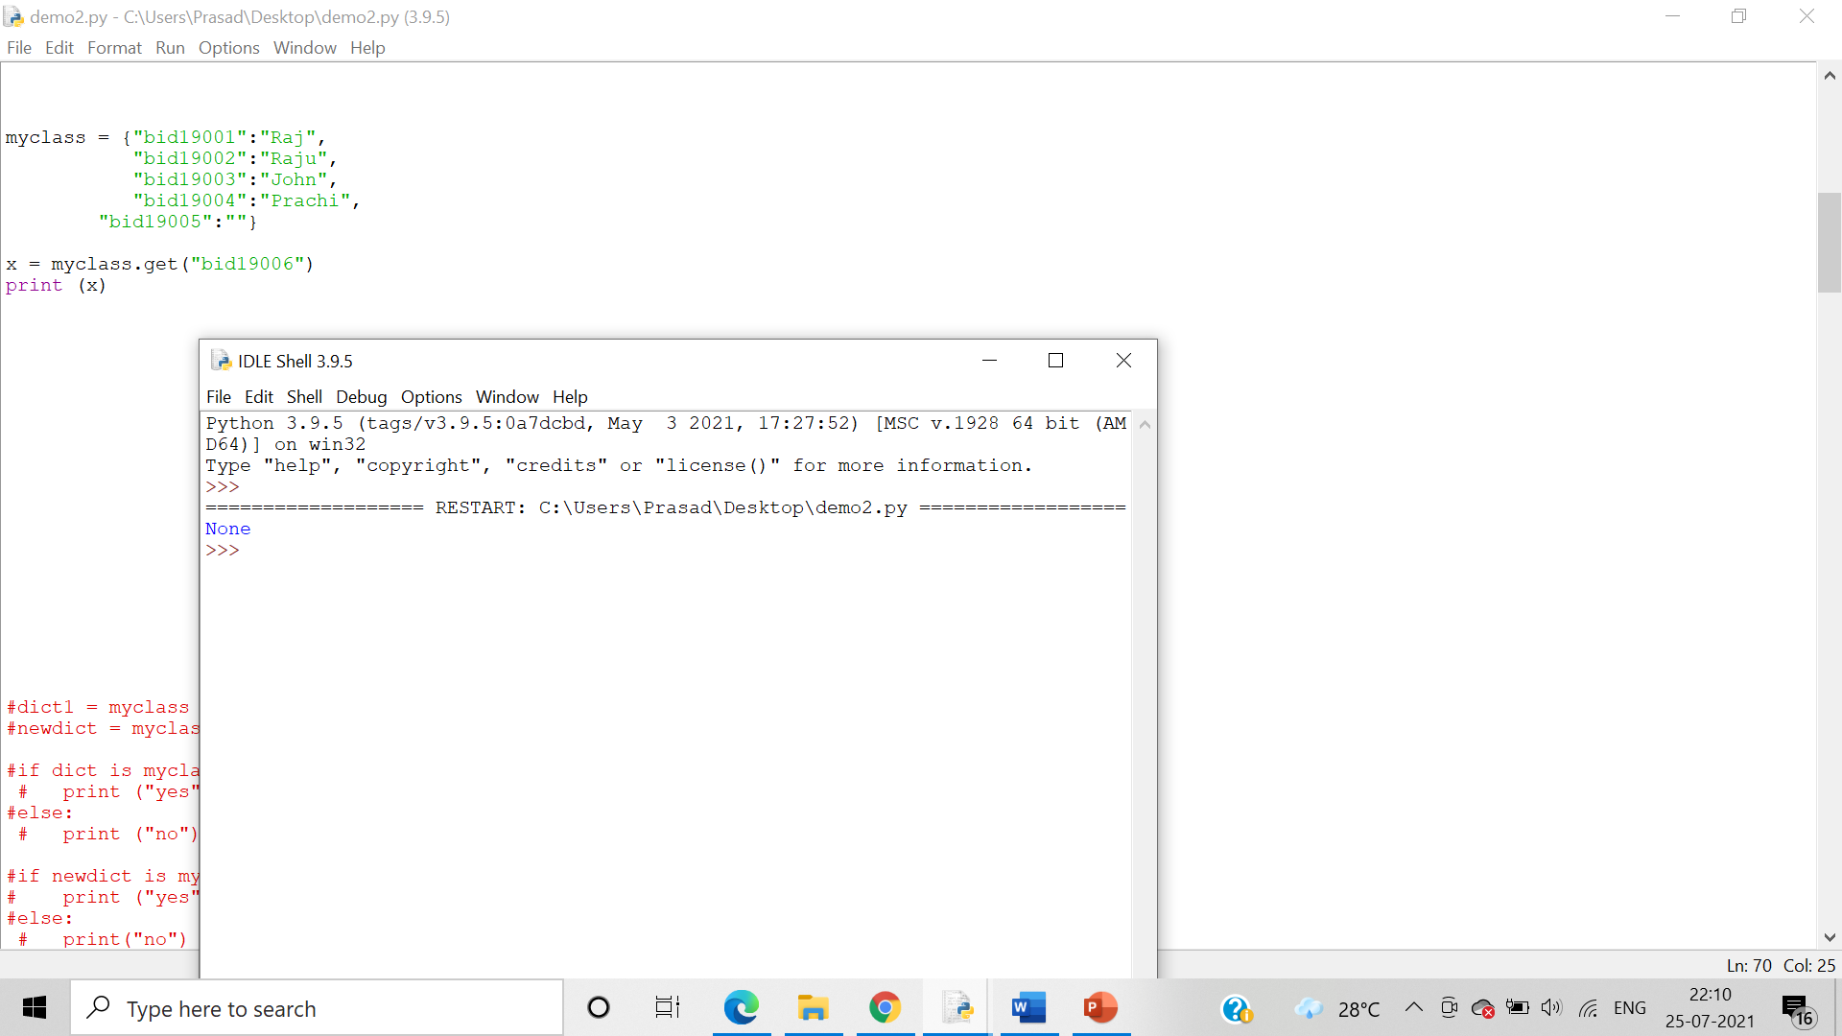

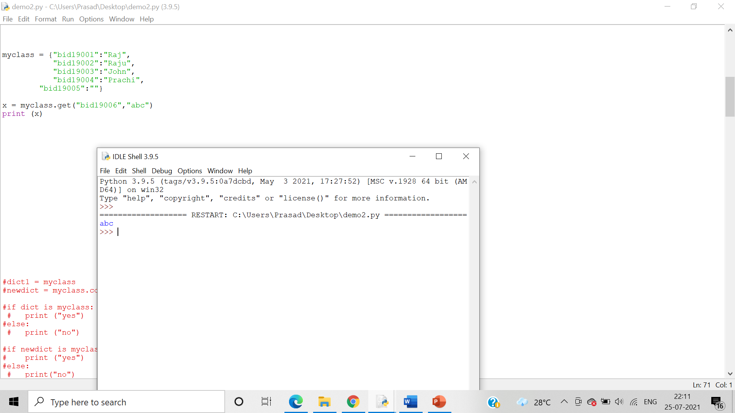

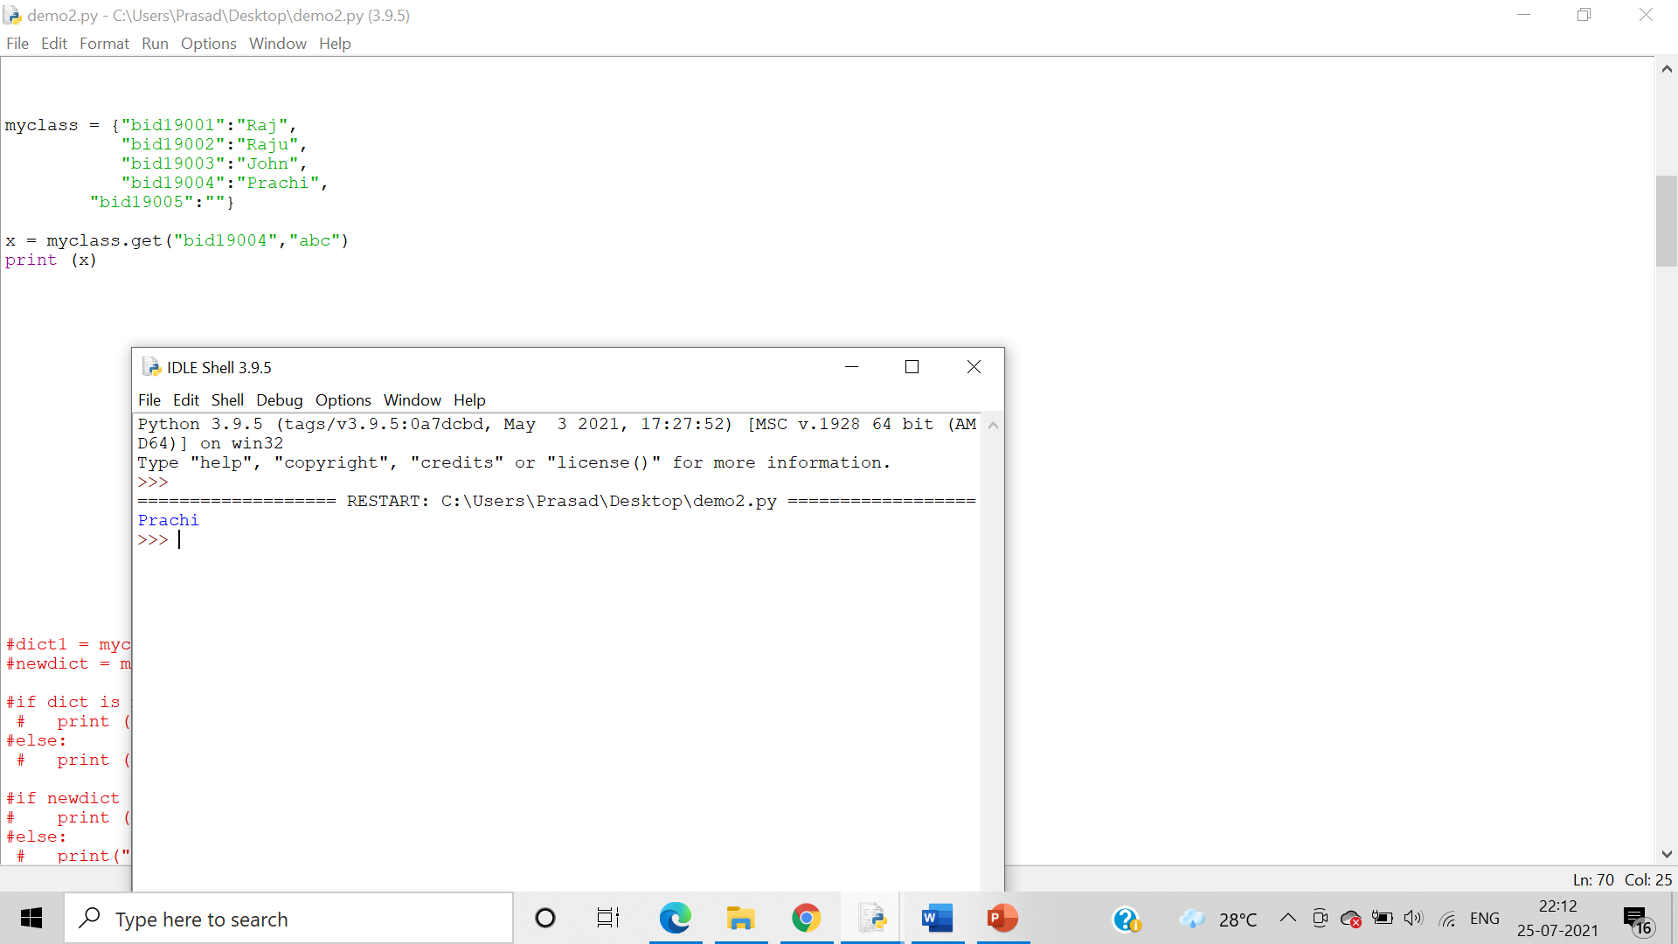

items()

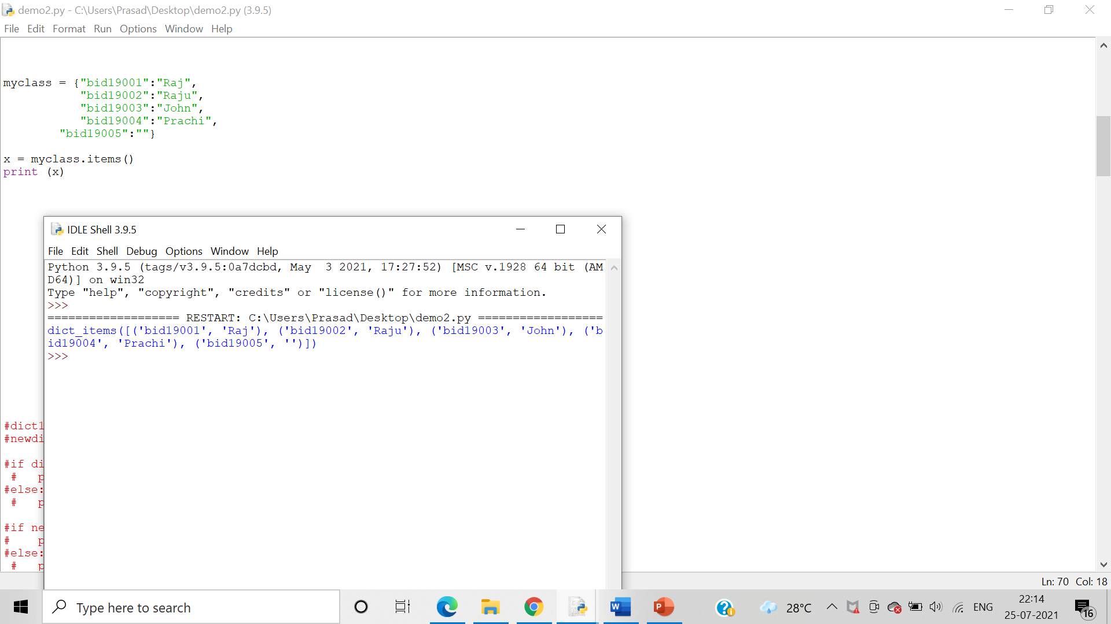

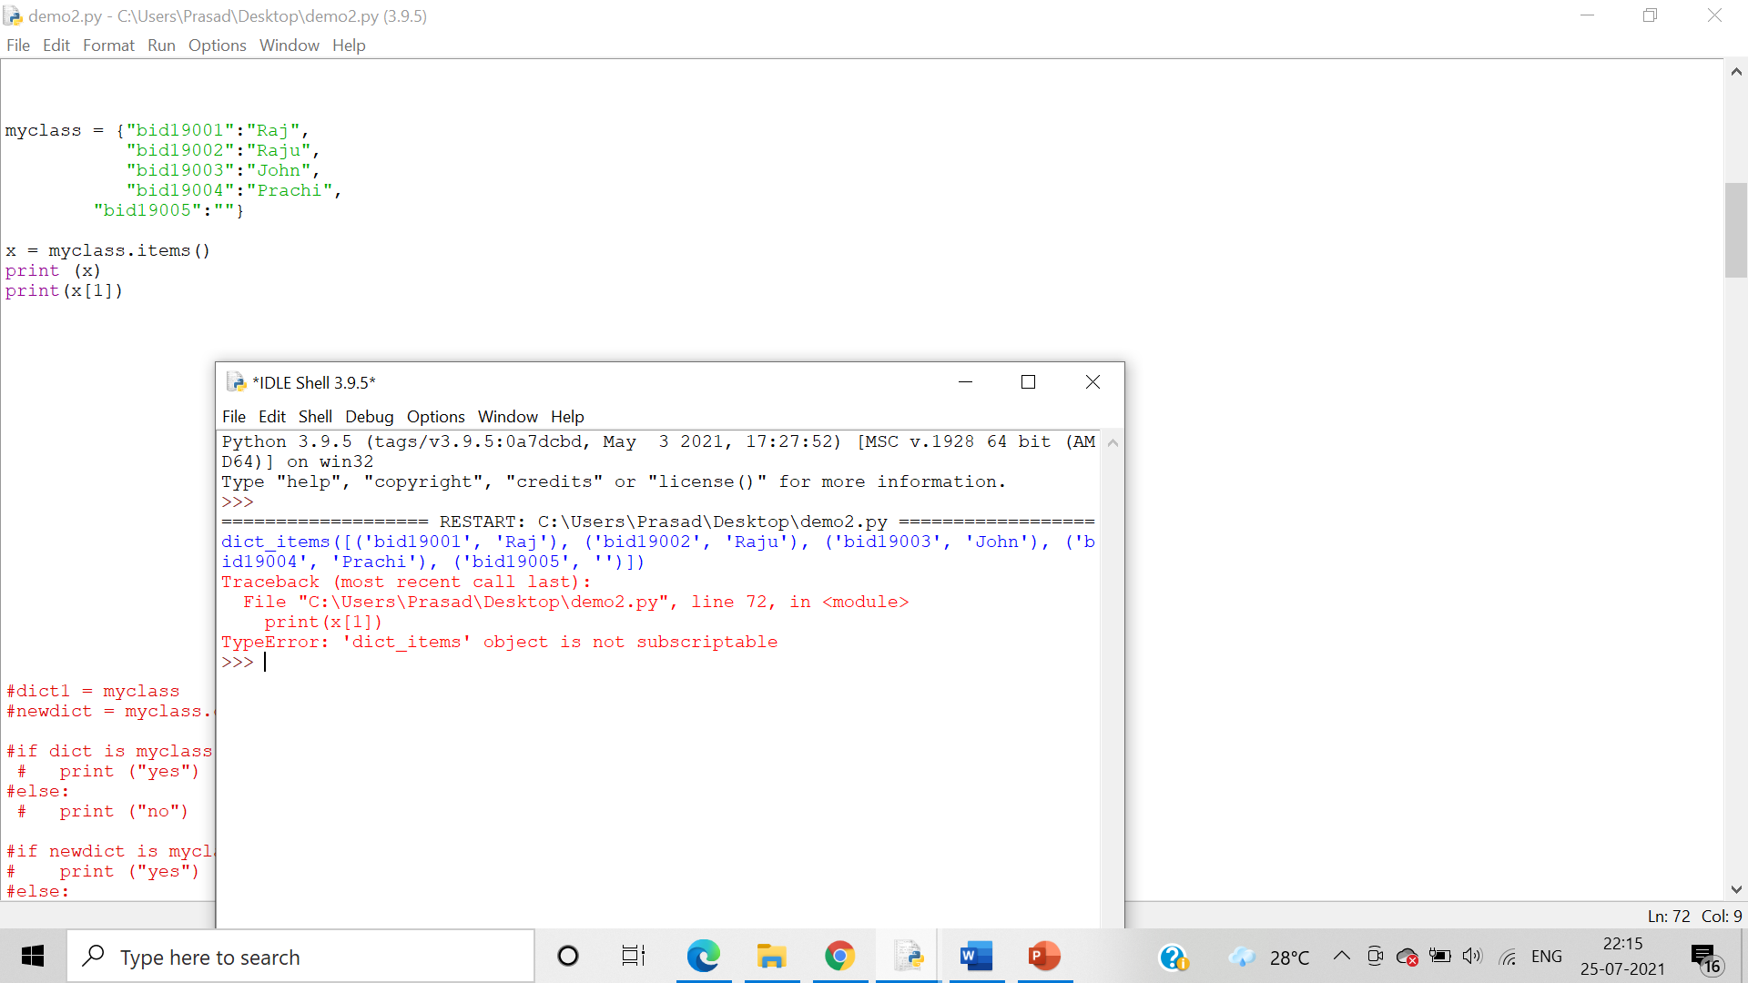

keys()

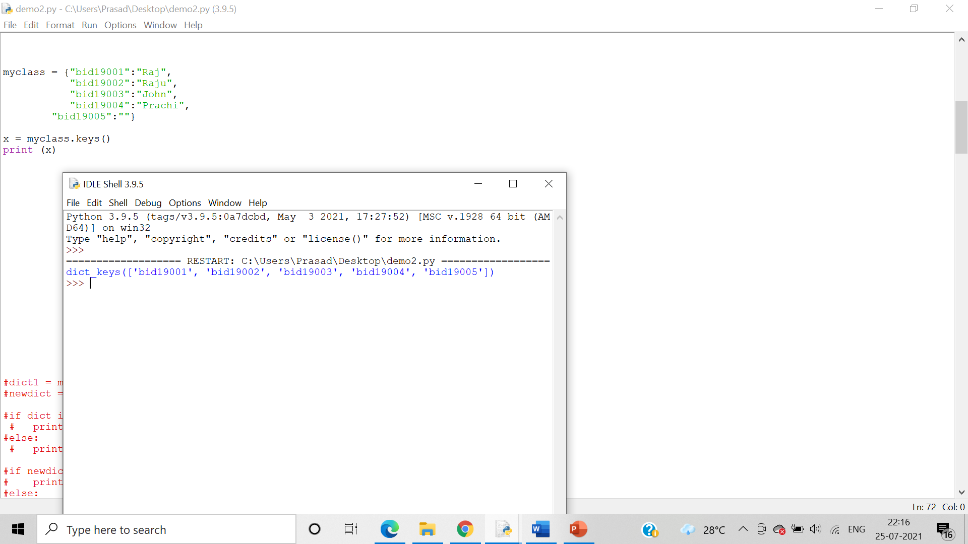

values()

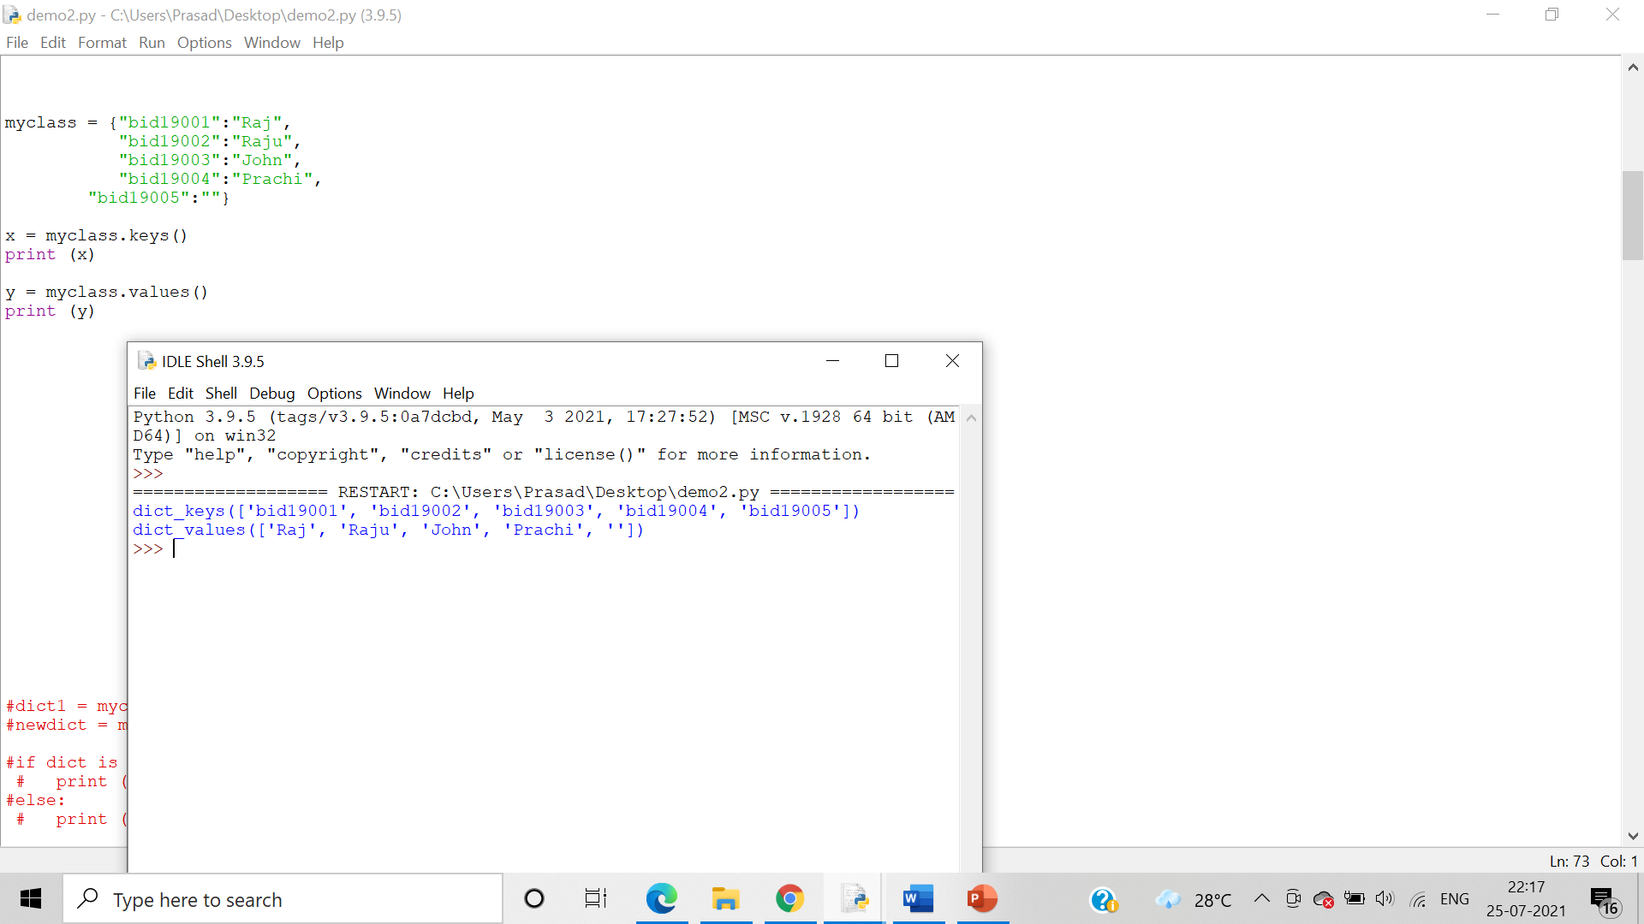

pop()

Algorithm:-

Step 1:- pop() removes the element with the specified key.

Step 2:- popitem() removes the last inserted key-value pair

Step 3:-setdefault() returns the value of the specified key. If the key does not exist: insert the key, with the specified value

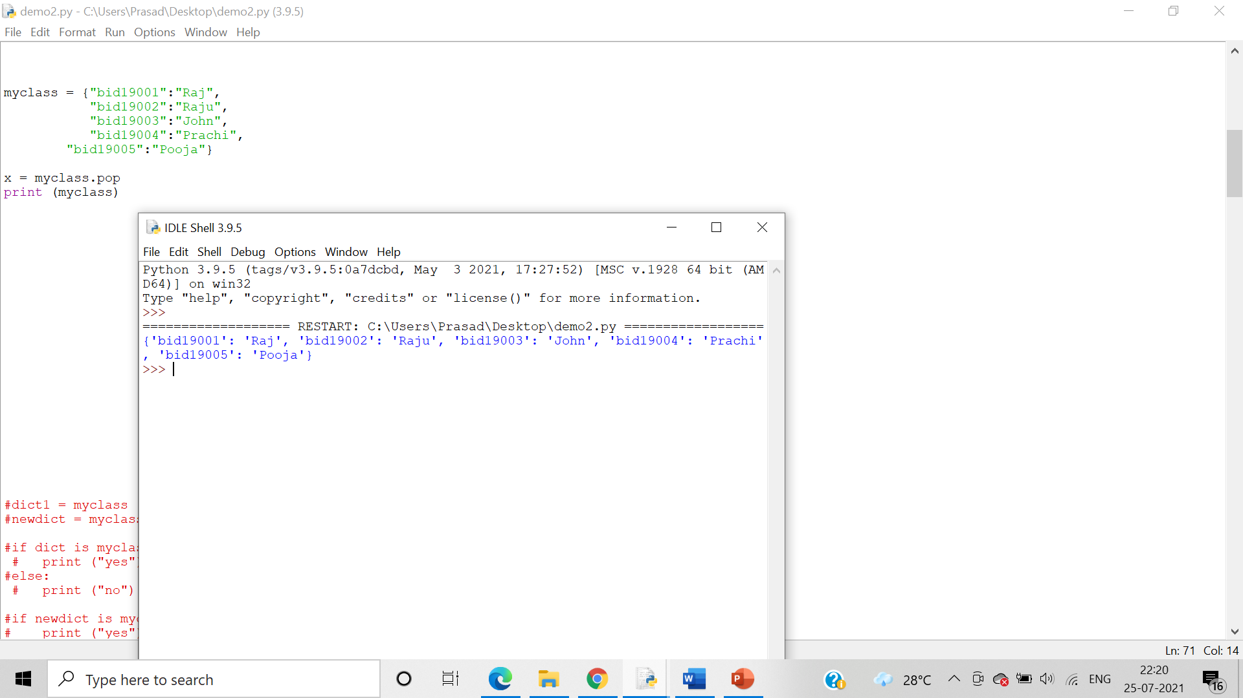

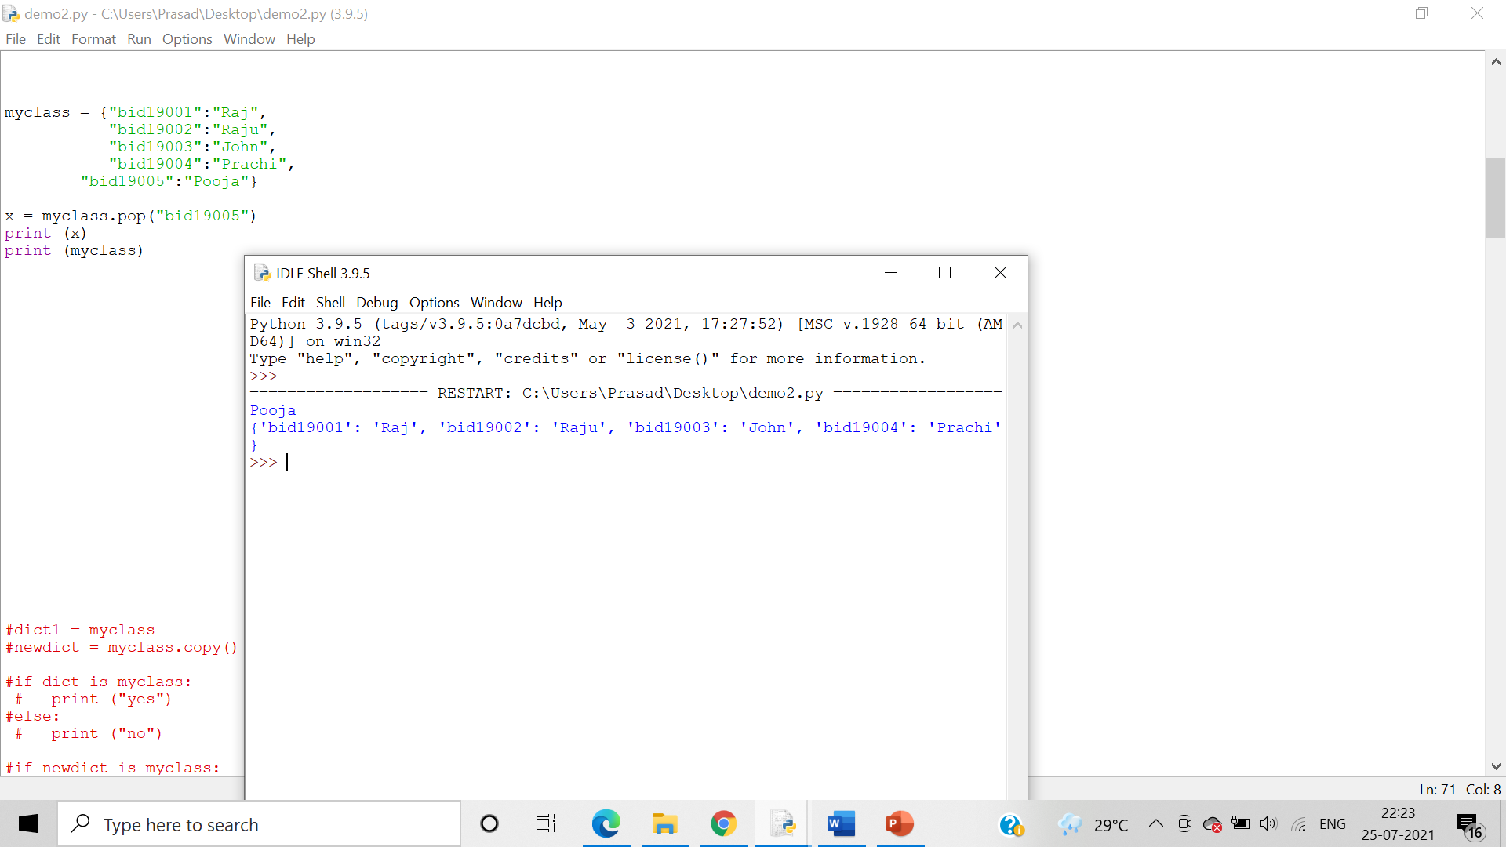

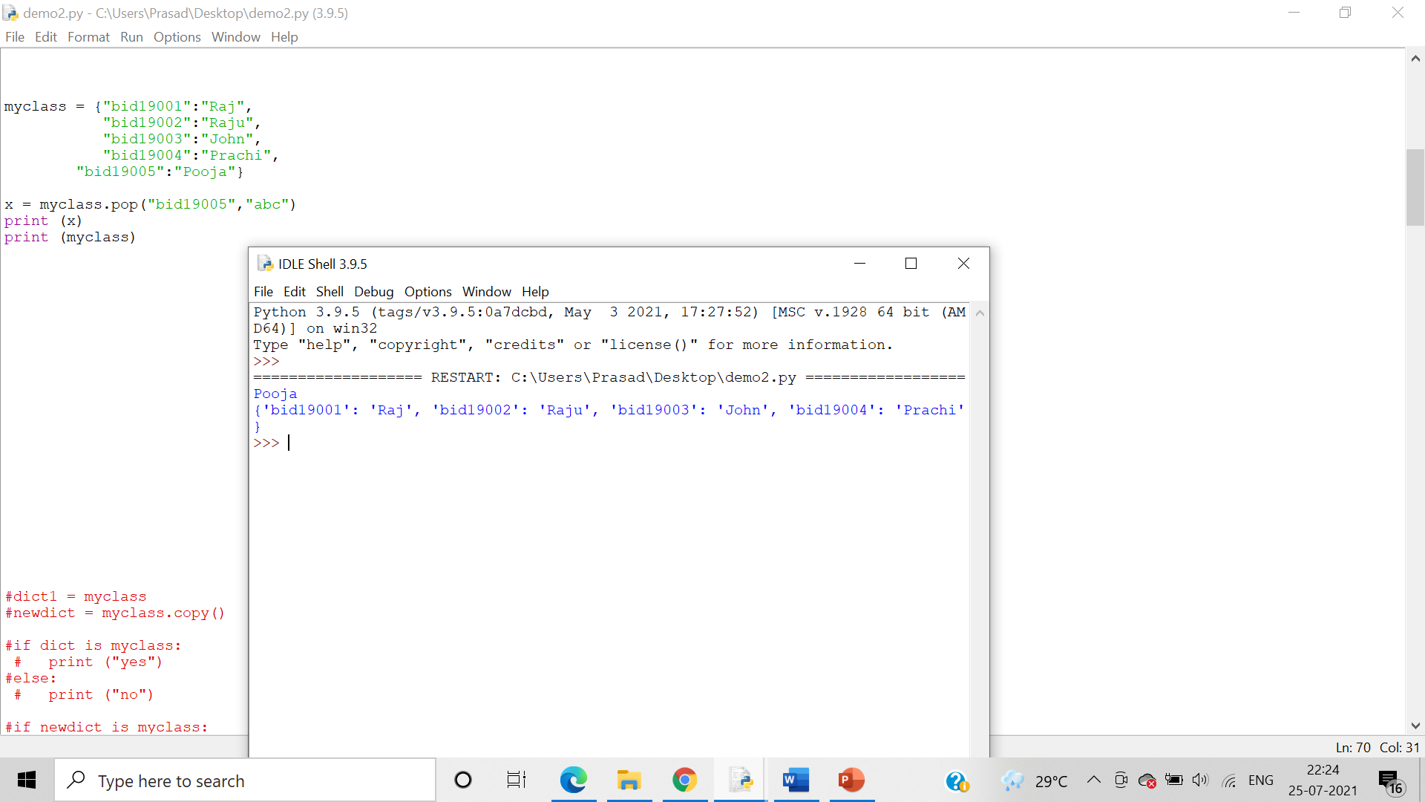

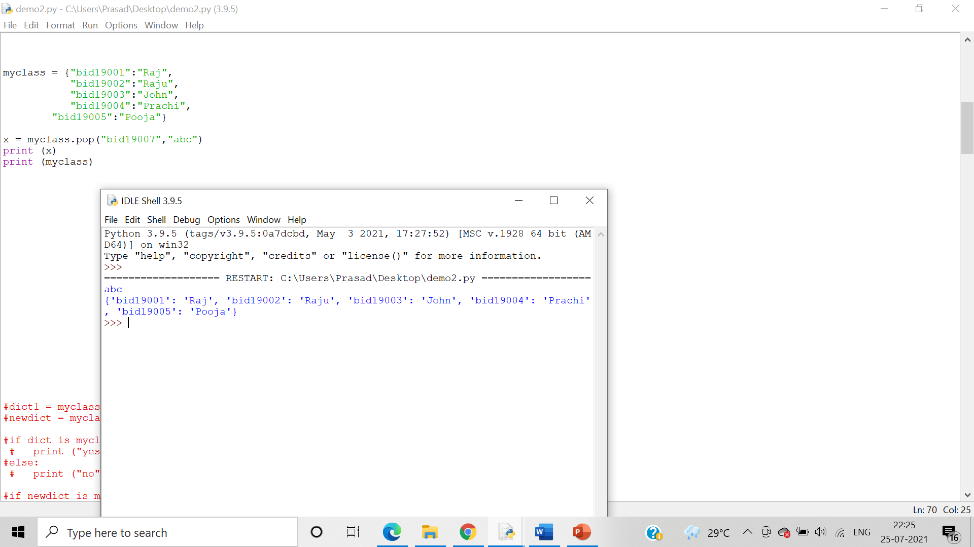

popitems()

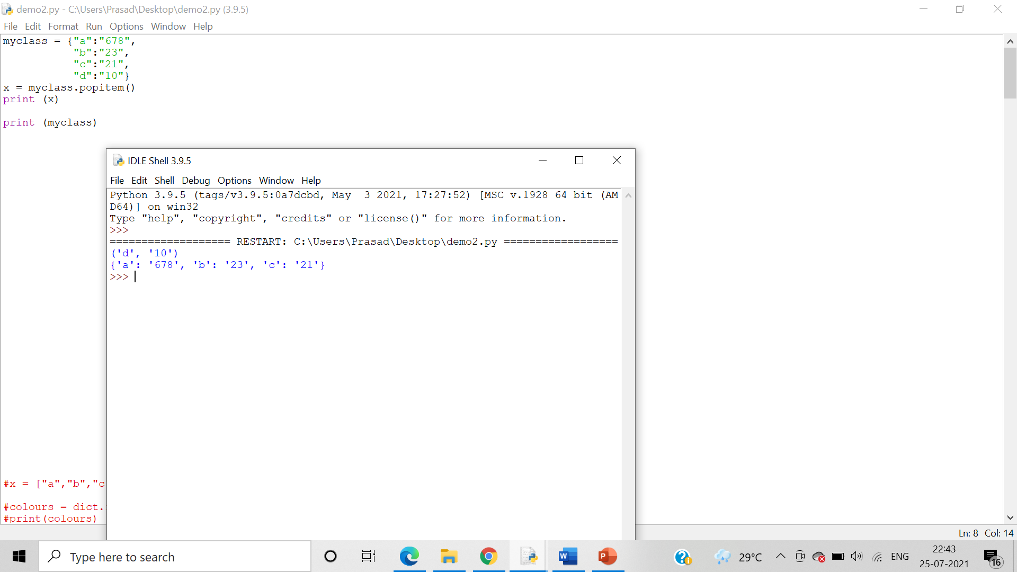

setdefault()

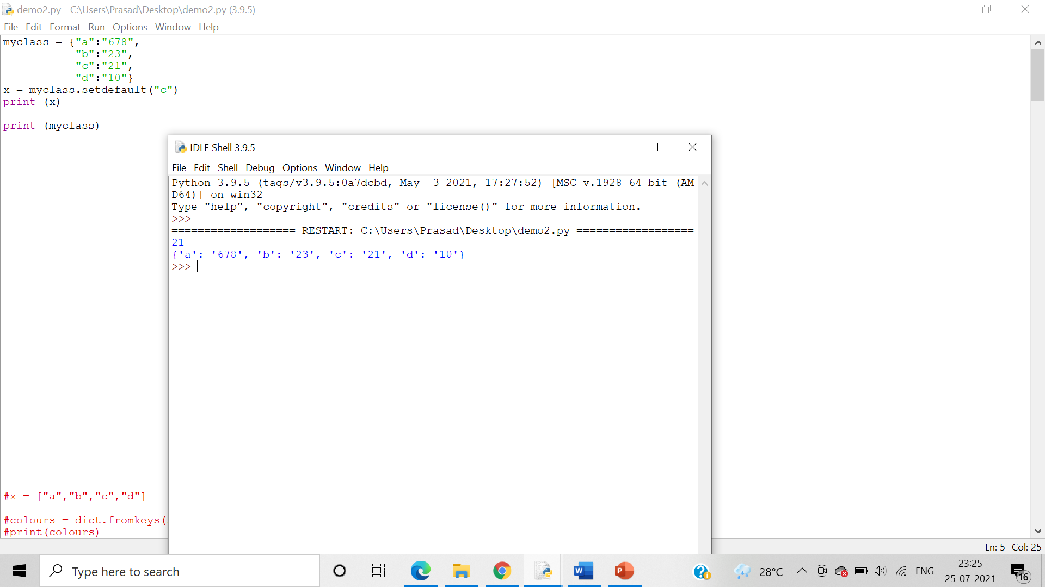

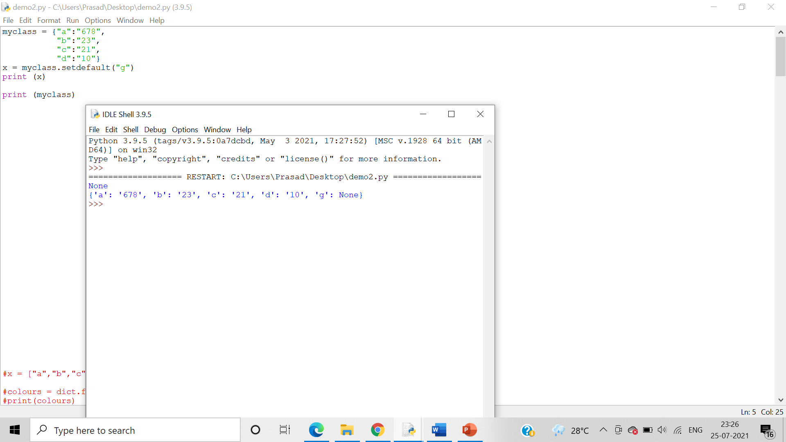

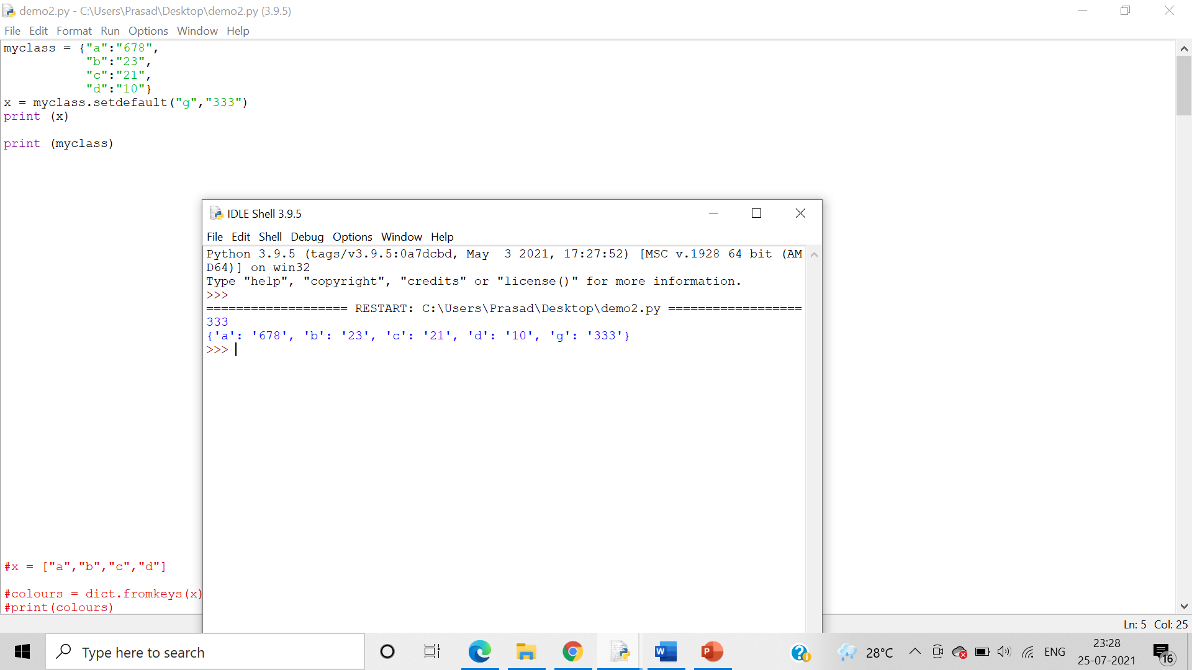

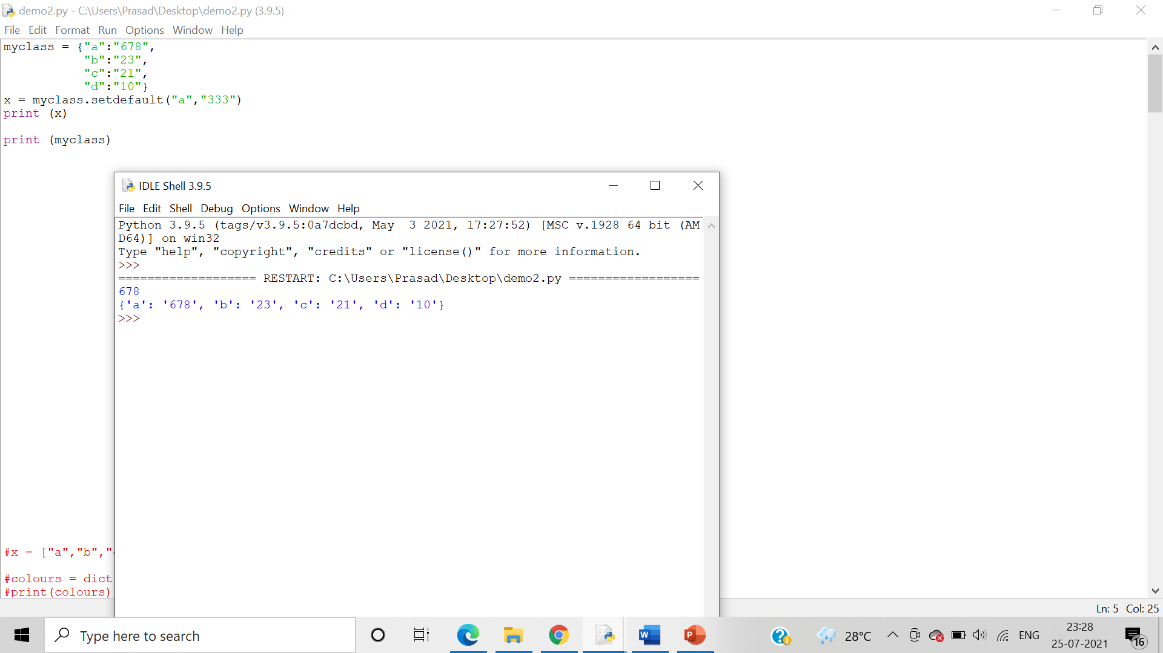

update()

Algorithm:-

Step 1:- update() updates the dictionary with the specified key-value pairs

Step 2:-values() returns a list of all the values in the dictionary

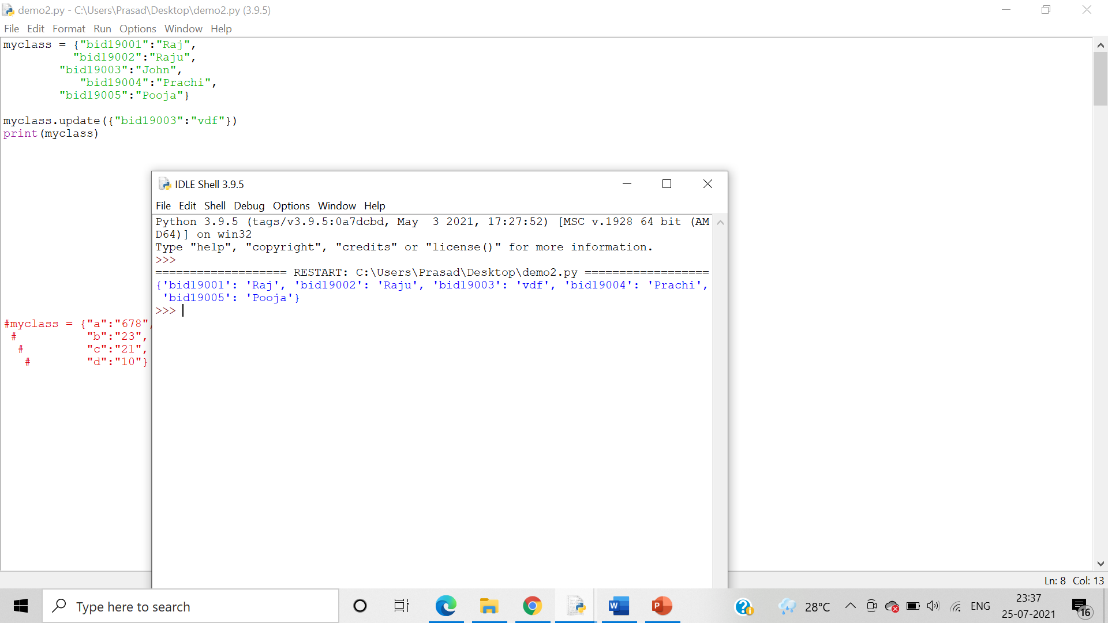

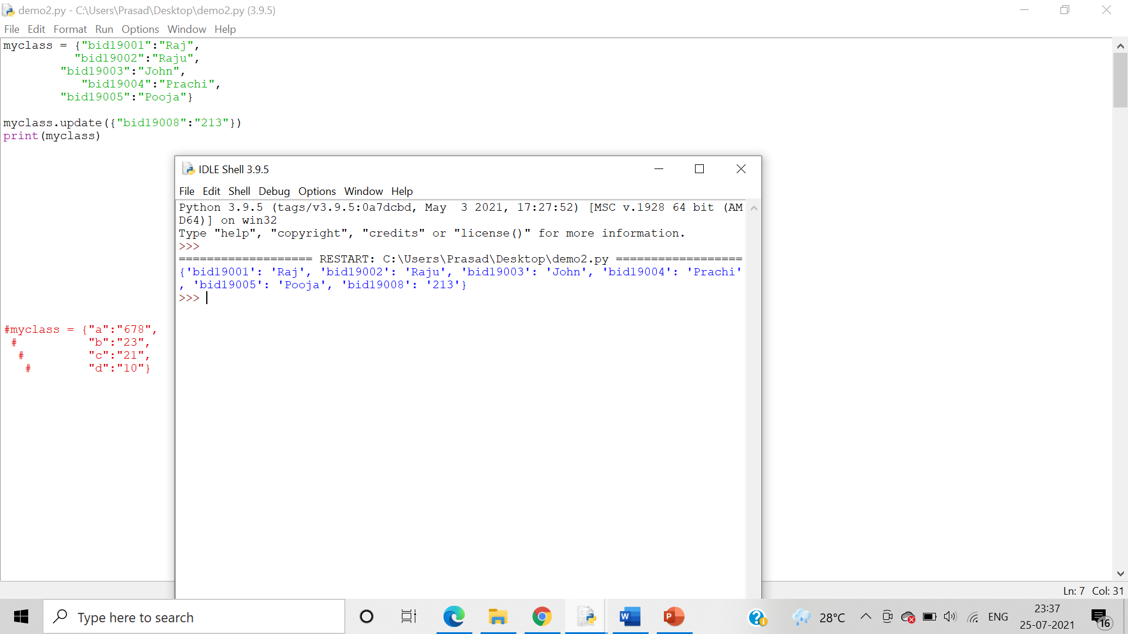

13. Demonstrate the usage of copy method

Algorithm:-

Step 1:-We create a dictionary and declare it.

Step 2:-We can then use copy() function to copy the keys and values In the first dictionary and assign it to the second dictionary.

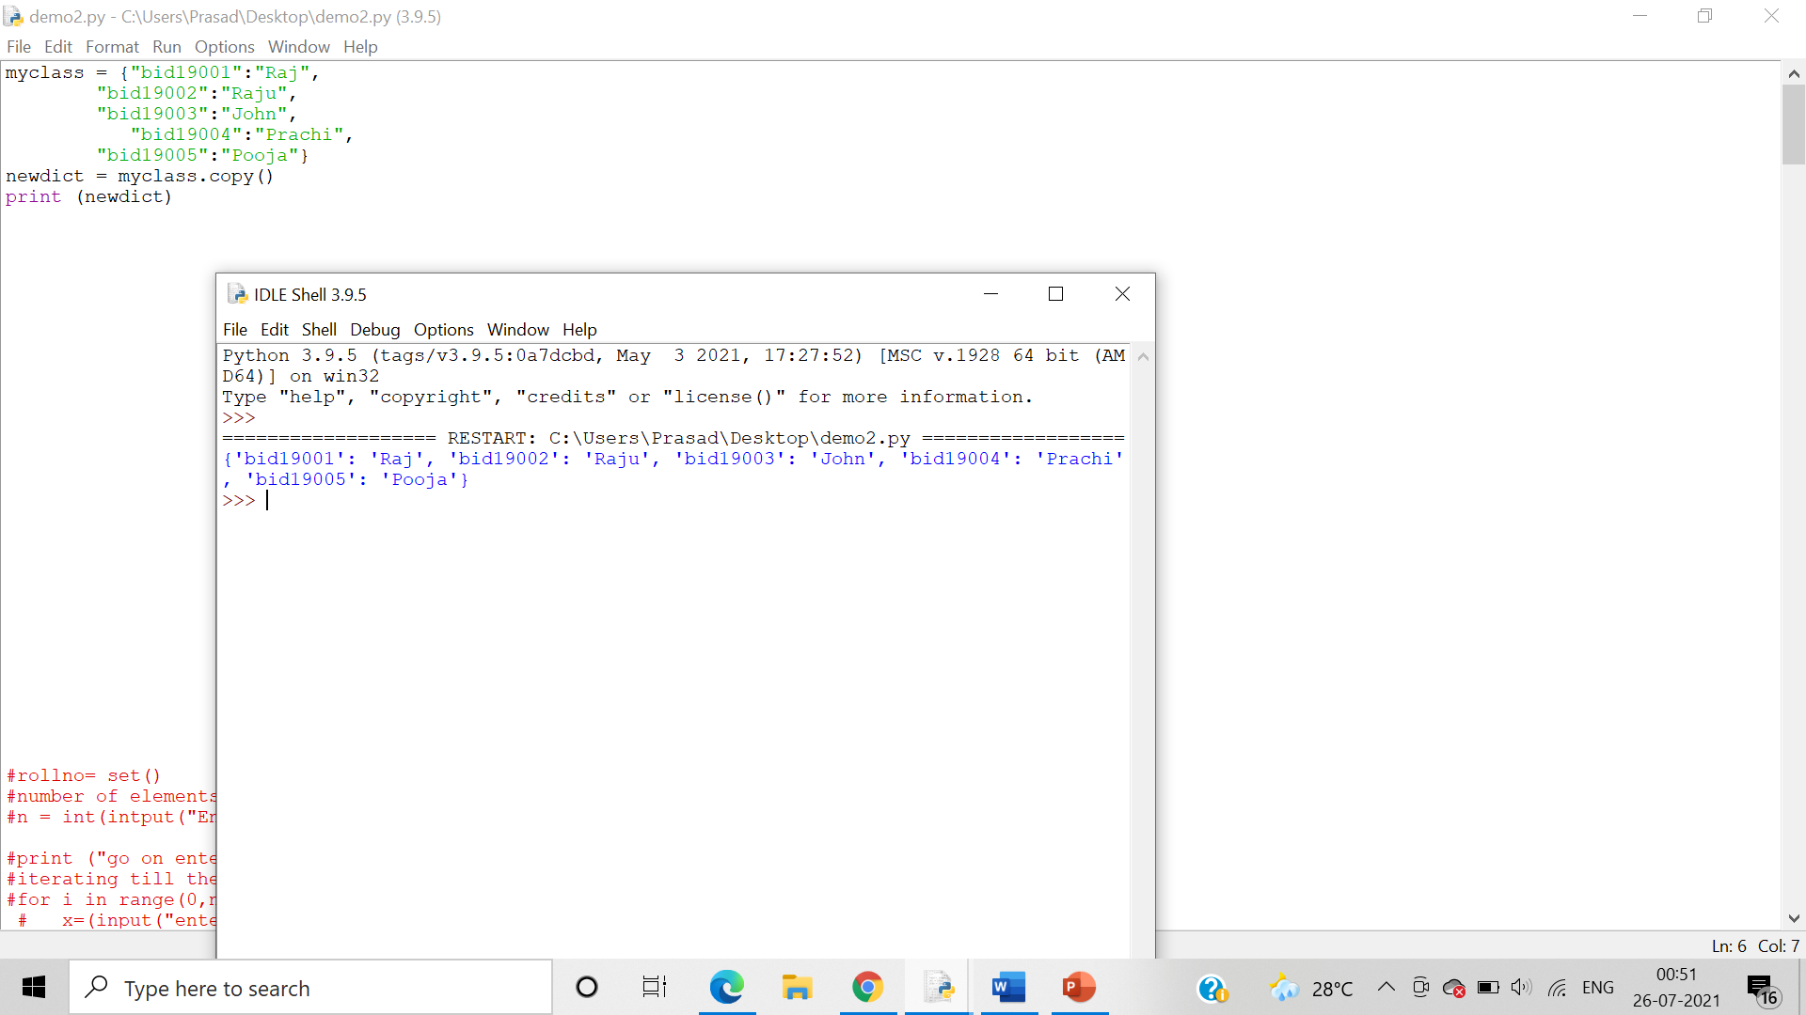

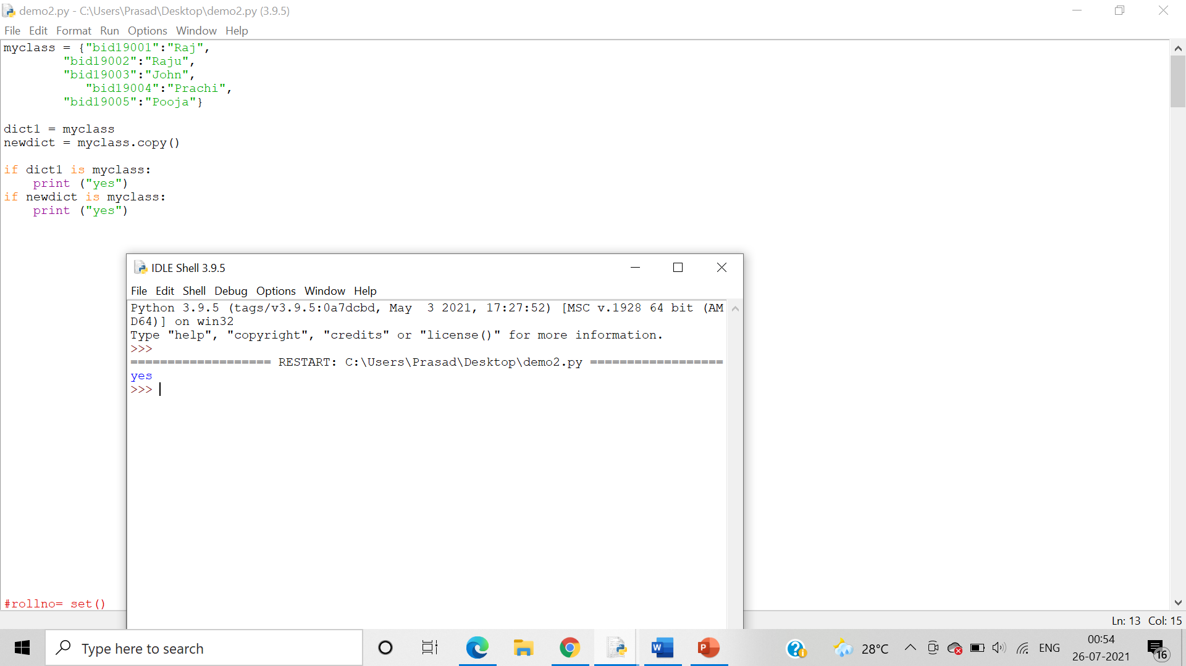

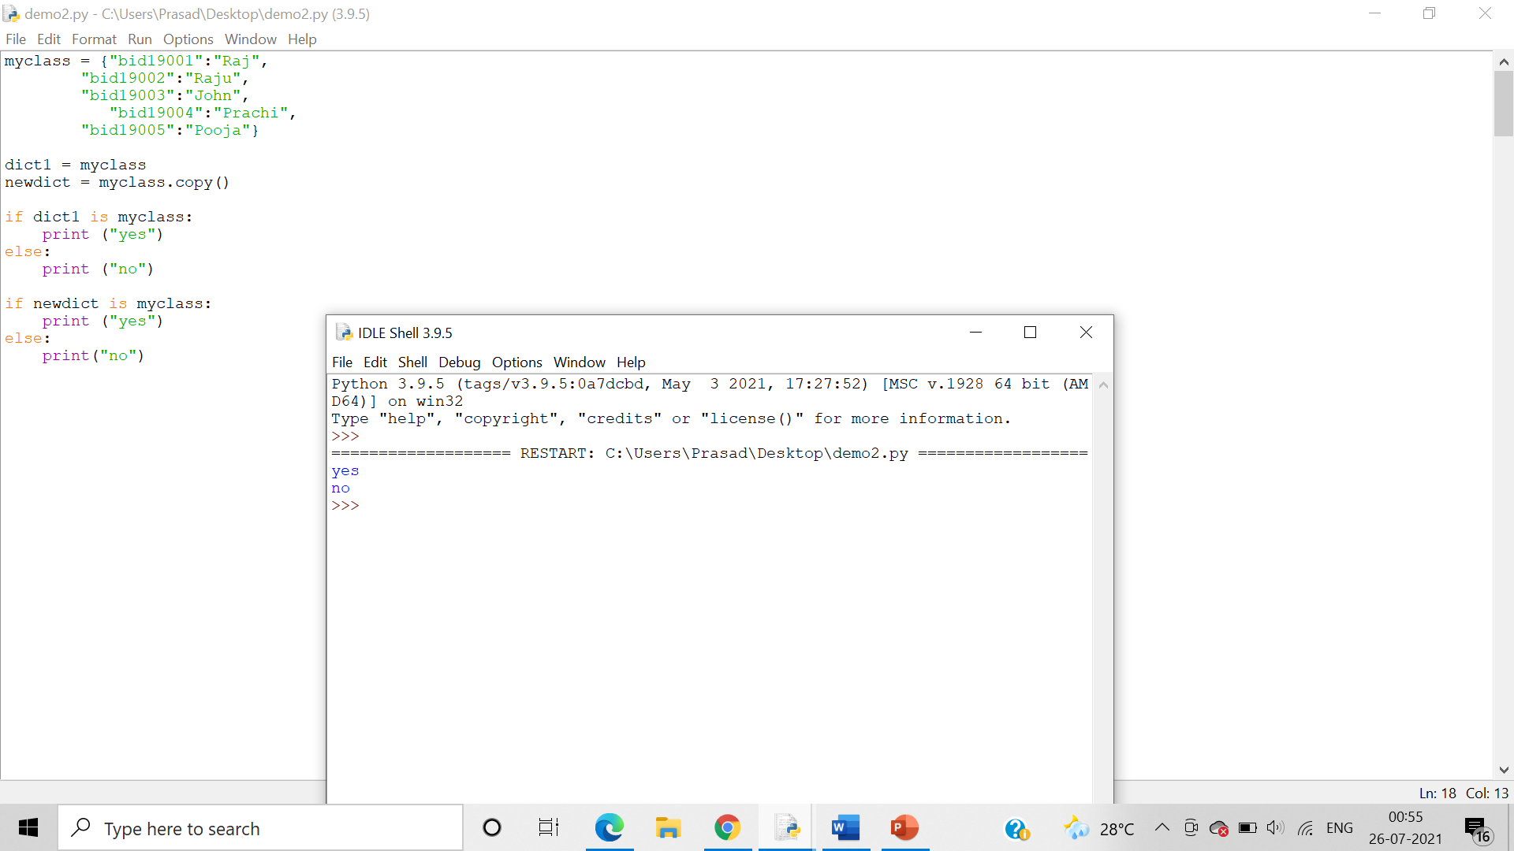

14. Write a program to merge two dictionaries.

15. Write a program to sort the elements of a dictionary in two ways - i) according to keys and ii) according to values

16. Write a Python script to print a dictionary where the keys are numbers between 1 and 15 (both included) and the values are square of keys.